**TMJ Contact Center Solution**

**Admin User Manual**

**Table of Contents**

**What is CCP?** 4

**Logging in to Amazon Connect (as an admin)** 4

**View Agents’ Basic Stats** 5

**Phone Number** 7

**Claiming a Phone Number** 7

**Configuring a Phone Number** 9

**Releasing a Phone Number** 10

**Hours of Operation** 11

**Creating an Hour of Operation** 11

**Editing Hours of Operation** 15

**Queue** 19

**Creating a Queue** 19

**Editing a Queue** 22

**Disabling a Queue** 25

**Routing Profile** 25

**Creating a Routing Profile** 25

**Editing a Routing Profile** 30

**User** 34

**Creating a User** 34

**Editing a User** 38

**Removing a User** 39

**Quick Connects** 40

**Creating a Quick Connect** 40

**Editing a Quick Connect** 44

**Real-Time Metrics** 45

**Checking Agents’ Real-Time Metrics** 45

**Saving Real-Time Metrics** 47

**Downloading Real-Time Metrics** 50

**Historical Metrics** 55

**Checking Agents’ Historical Metrics** 55

**Saving Historical Metrics** 57

**Downloading Real-Time Metrics** 60

# **What is CCP?**

Amazon Connect is a cloud-based contact center solution. It provides rich metrics and real-time reporting that allow you to optimize contact routing.

***Note: Data used in the screenshots are dummy and only used for documentation and testing purposes. Any resemblance in names, places, or other things are purely coincidental and should therefore be ignored.***

# **Logging in to Amazon Connect (as an admin)**

* To start using Amazon Connect, the admin should first log into their account. Following this link will redirect you to the log in form of your account:

User Acceptance Testing (UAT) Link: <https://tmjccs-test.awsapps.com/connect/home>

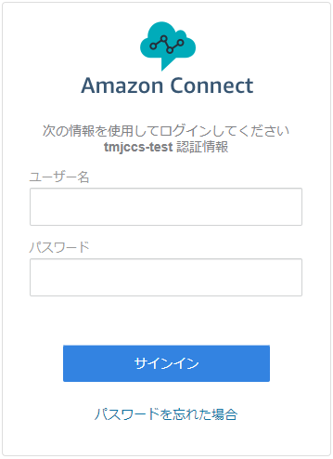

Figure 1. Amazon Connect Log-In Form

* Type your username and password in the input boxes. Then, click on the blue “Sign In” button.

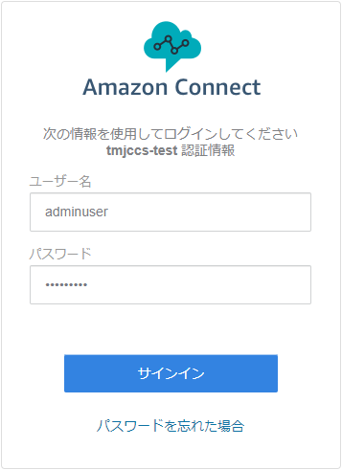

Figure 2. Inputting credentials in the Log-In Form

* Wait for a few moments and you will be redirected to Amazon Connect dashboard.

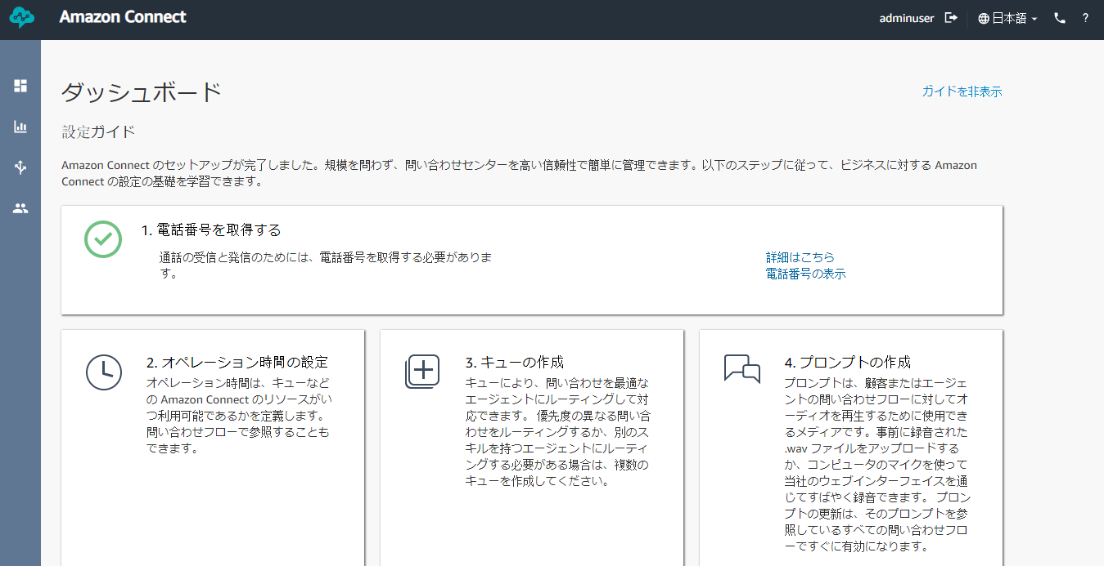

Figure 3. Amazon Connect Admin Dashboard

* You are now logged into your Amazon Connect account.

# **View Agents’ Basic Stats**

* You can view your agents’ basic stats directly in the front page of your dashboard. Simply click the “Hide the Guide” link on the upper-right corner of the dashboard to hide the configuration guide and bring the charts to the top.

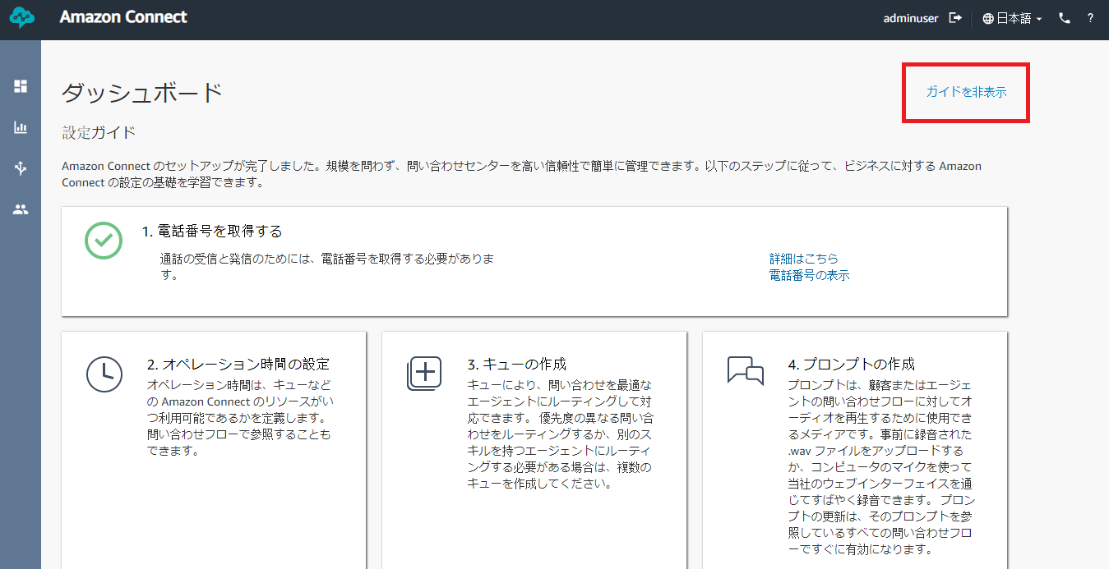

Figure 4. Hide the Guide Link in Amazon Connect Dashboard

* You will see cards of queues showing an overview on the agents handling those queues.
  + **SL** (Service Level) – percentage of contacts removed from the queue between 0 and the specified number of seconds after being added to it (Service Level). A contact is removed from the queue when one of the following occurs: an agent answers the call, the customer abandons the call, or the customer requests a call back. The possible values for seconds are: 15, 20, 25, 30, 45, 60, 90, 120, 180, 240, 300, and 600.
  + **Occ** (Occupancy) – percentage of time that agents spend handling contacts against the available and idle time.
  + **AHT** (Average Handled Time) – average time, from start to finish, that a contact was connected with an agent. This is calculated by averaging the amount of time between the contact being answered by an agent and the contact ending.
  + **Avl** (Available) – number of agents with a status of *Available*.
  + **On Call** – number of agents currently on a call.
  + **NPT** (Non-Productive Time) – number of agents in a status other than *Available*, *Error*, or *Offline*.)

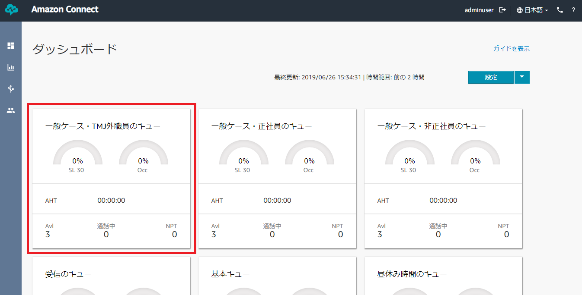

Figure 5. Basic Stats

# **Phone Number**

## **Claiming a Phone Number**

***Prerequisites:***

1. *Contact flow (optional)*

* Hover over the third icon in the left navigation bar and click on “Phone numbers”.

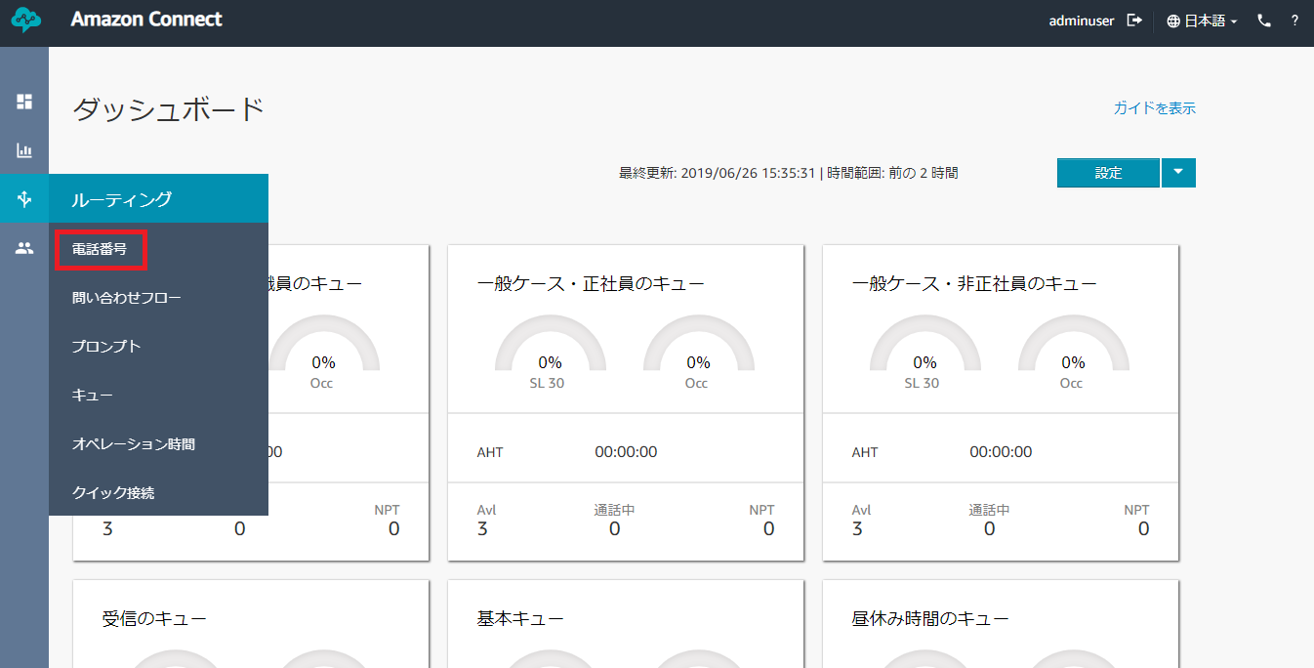

Figure 6. Phone Numbers Link in Routing

* Click on the blue “Claim a number” button to go to phone number claiming form.

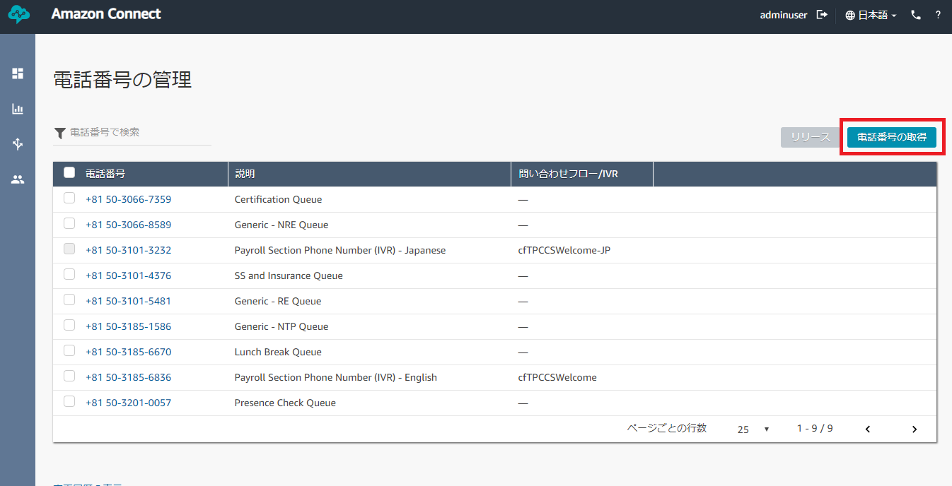

Figure 7. Claim a Number Button

* Choose between “Toll Free” and “DID”.
  + Toll Free – caller will be able to call the number free of charge.
  + DID (Direct Inward Dialing) – caller will be charged regularly.

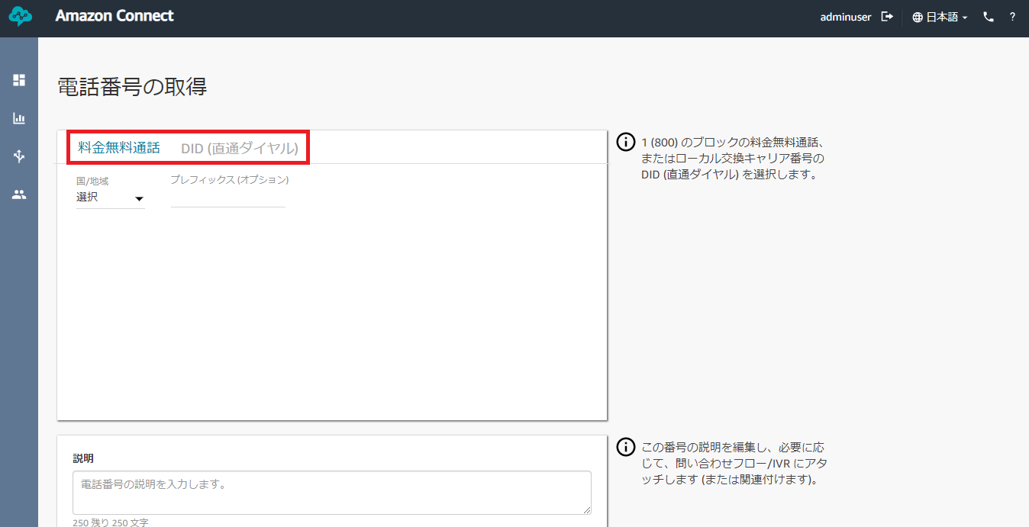

Figure 8. Toll Free or DID Option

* Click on “Select” and choose “Japan”. It will enable you to create a number with Japan’s area code. This will also generate various phone numbers that you can claim.

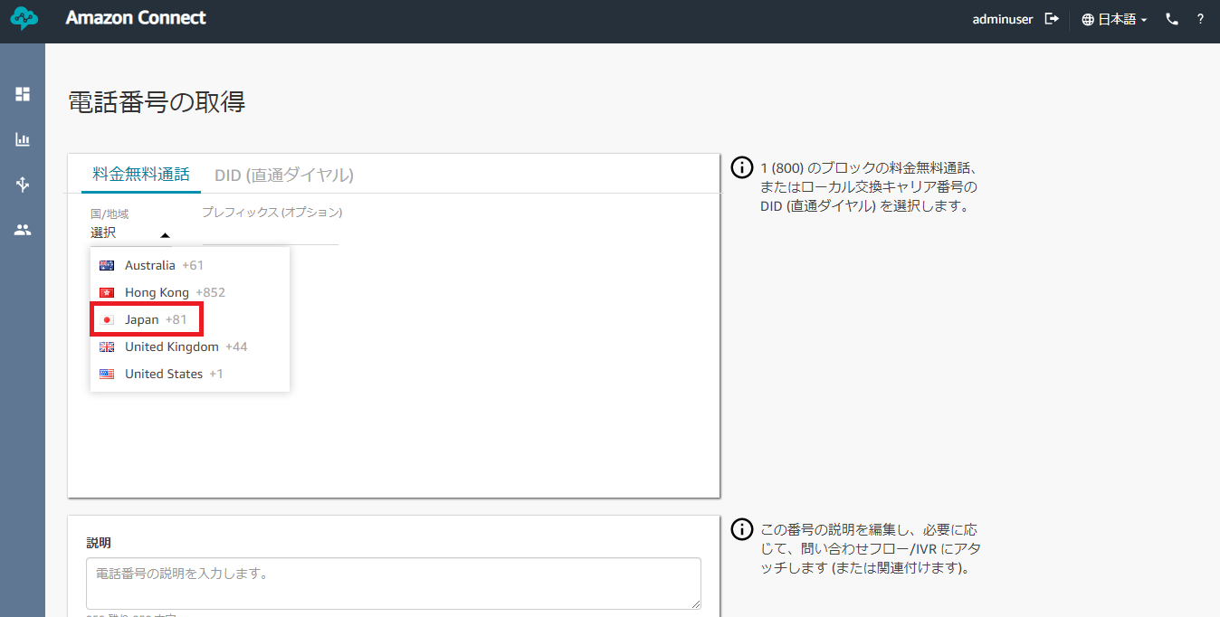

Figure 9. Japan Area Code

* Pick among the phone numbers generated by Amazon Connect.

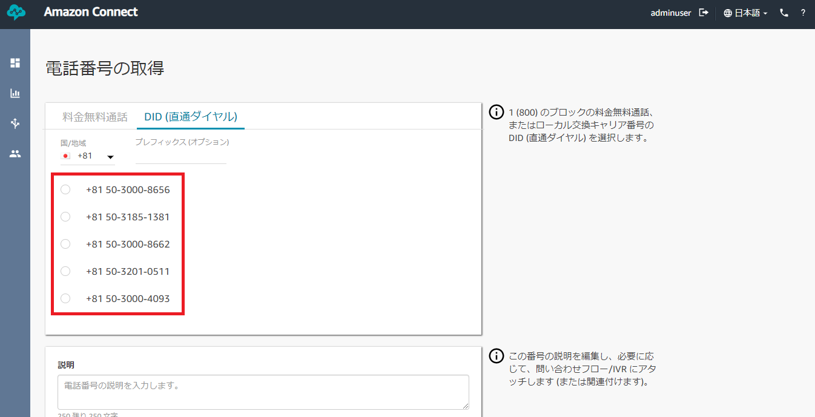

Figure 10. Phone Numbers Generated by Amazon Connect

* *Optional:* You can also add a prefix, description and a contact flow to your phone number. The contact flow you assigned to the phone number will be the flow that the caller will go through when they called the number.
* Click on the blue “Save” button to claim the number you chose.

## **Configuring a Phone Number**

* To change the description or the contact flow of the phone number, you can configure it by clicking on the phone number.

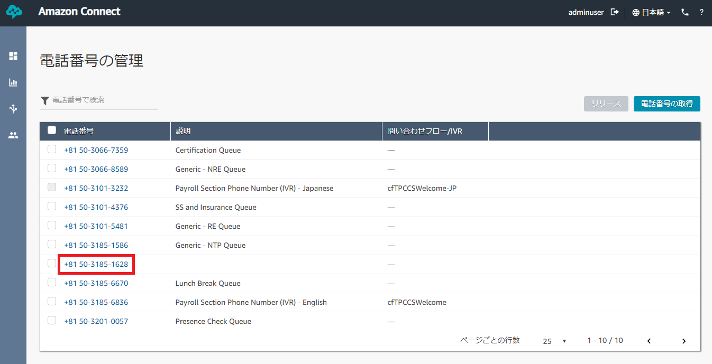

Figure 11. Configuring Phone Number

* Edit the details you need to change and click “Save”.

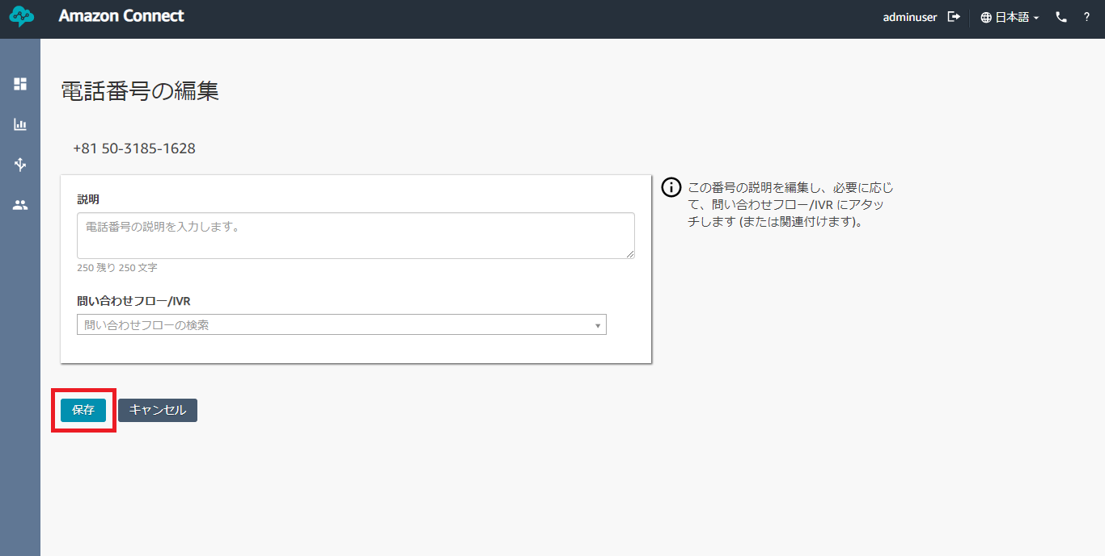

Figure 12. Phone Number Configuration Form

## **Releasing a Phone Number**

* If you want to remove a number, check the number you want to remove. Then, click the “Release” button.

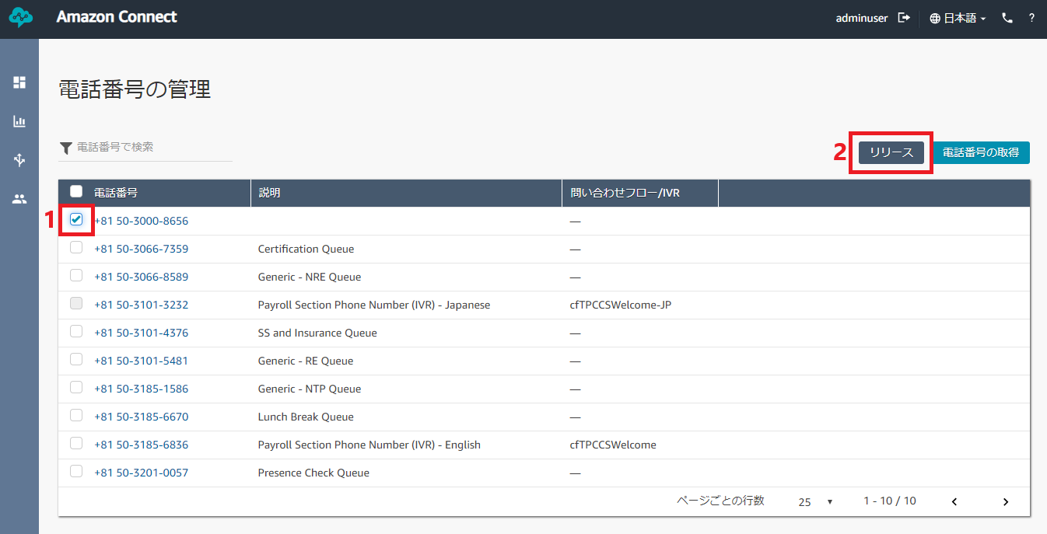

Figure 13. Steps to Release a Number

* A modal will appear to confirm your action. Click on the red “Remove” button to remove the number. This action is irreversible.

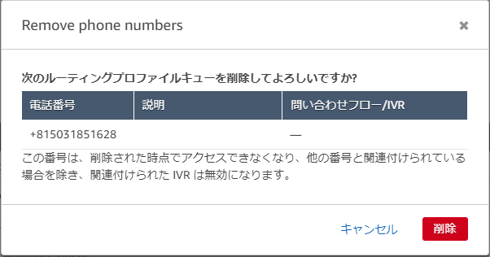

Figure 14. Phone Number Releasing Confirmation Modal

# **Hours of Operation**

## **Creating an Hour of Operation**

*Note: As of now, Hours of Operation* ***cannot be deleted****. Amazon hasn’t implemented the function yet. Be careful of creating new Hour of Operation. Alternatively, you can modify existing hours of operation to suit your preference.*

* Hover over the third icon in the left navigation bar and click on “Hours of operation”.

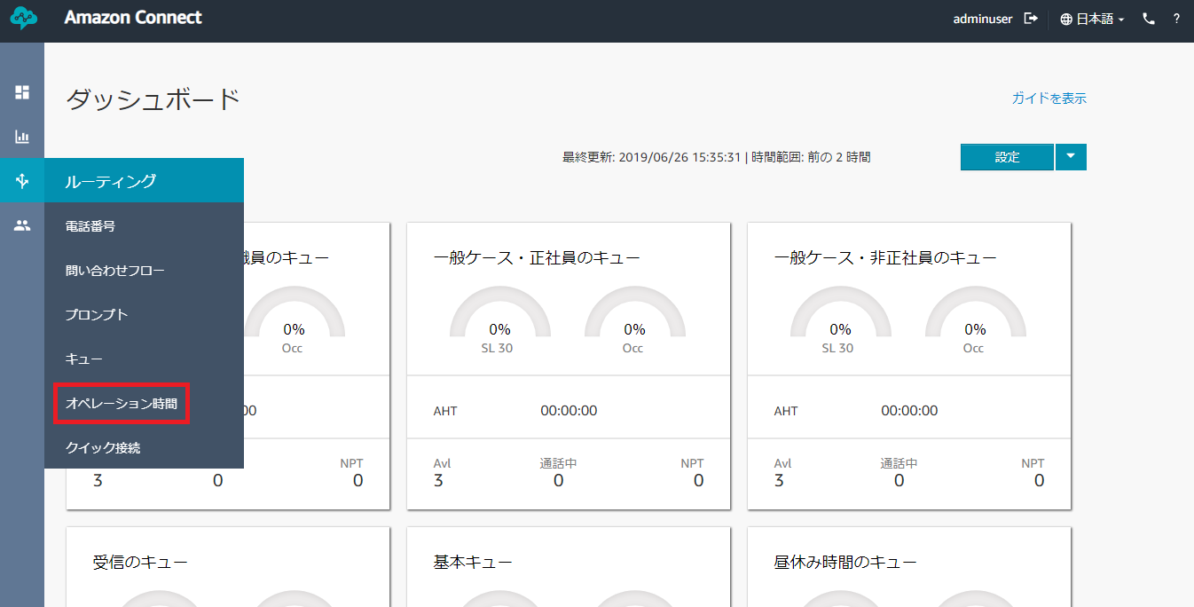

Figure 15. Hours of Operation Link in Routing

* Click on “Add new hours” button on the upper-right corner of the page. This will take you to the hours of operation creation form.

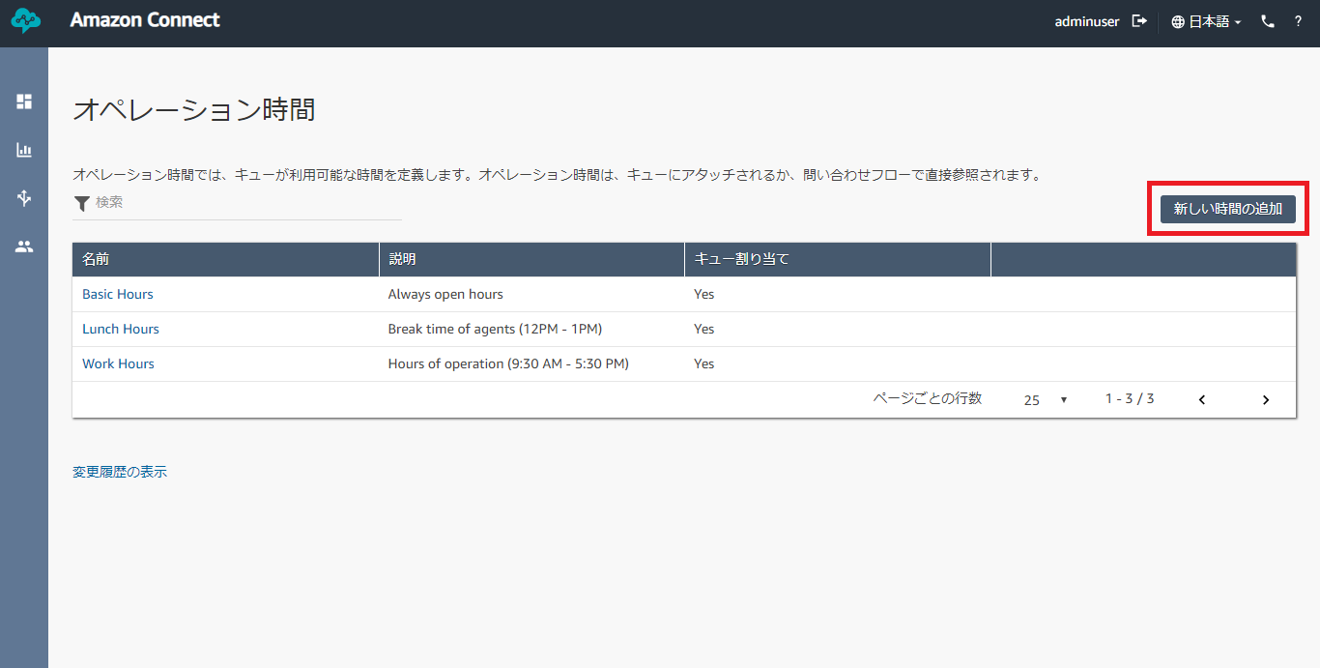

Figure 16. Adding New Hours of Operation

* Add a name for the hours of operation you are creating.

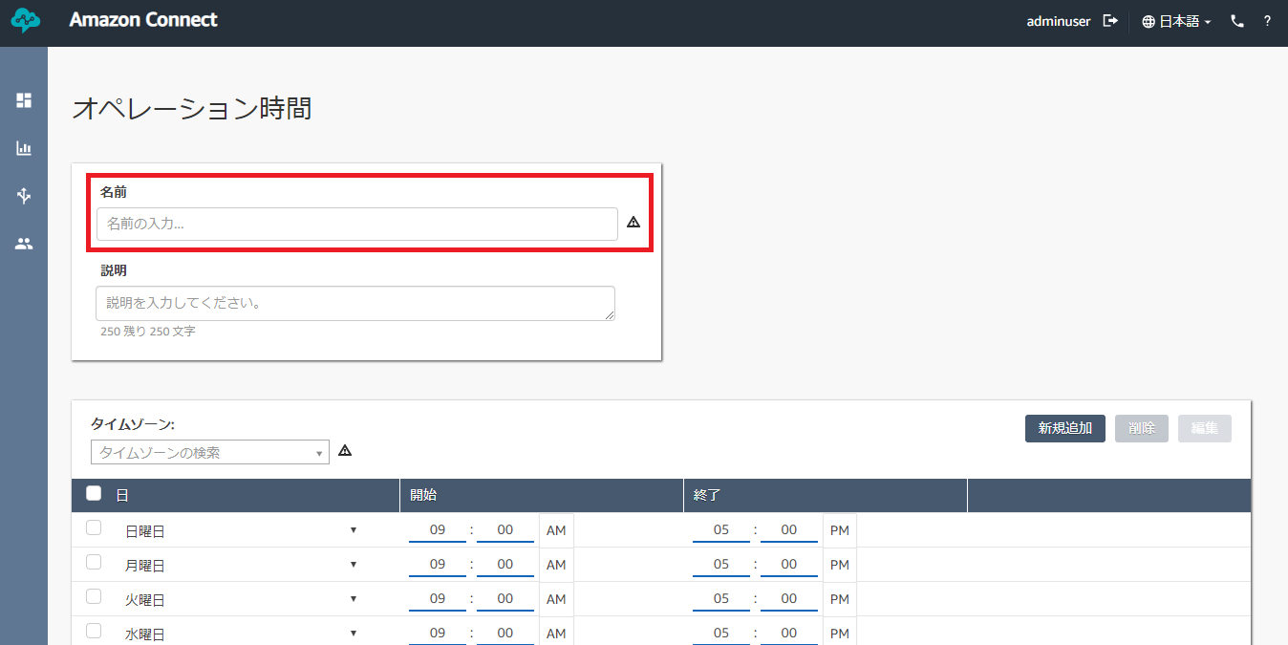

Figure 17. Hour of Operation Creation Form

* Then choose a Time zone. For Japan, you can choose “Asia/Tokyo” among the dropdown list.

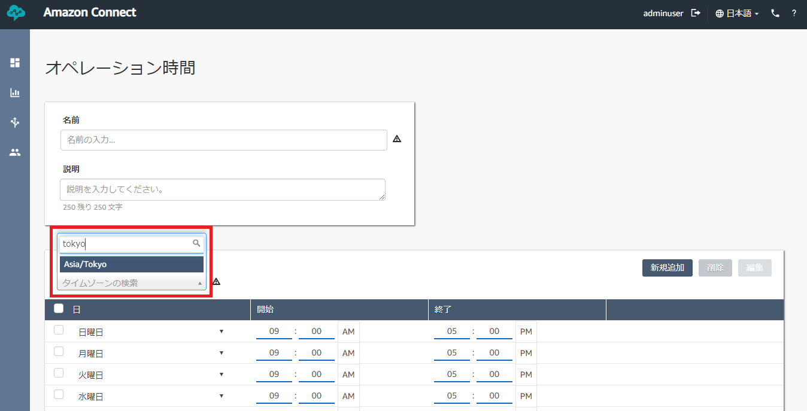

Figure 18. Hours of Operation Time Zone

* Change the time according to your preferred hours. Toggle AM and PM by clicking on them.

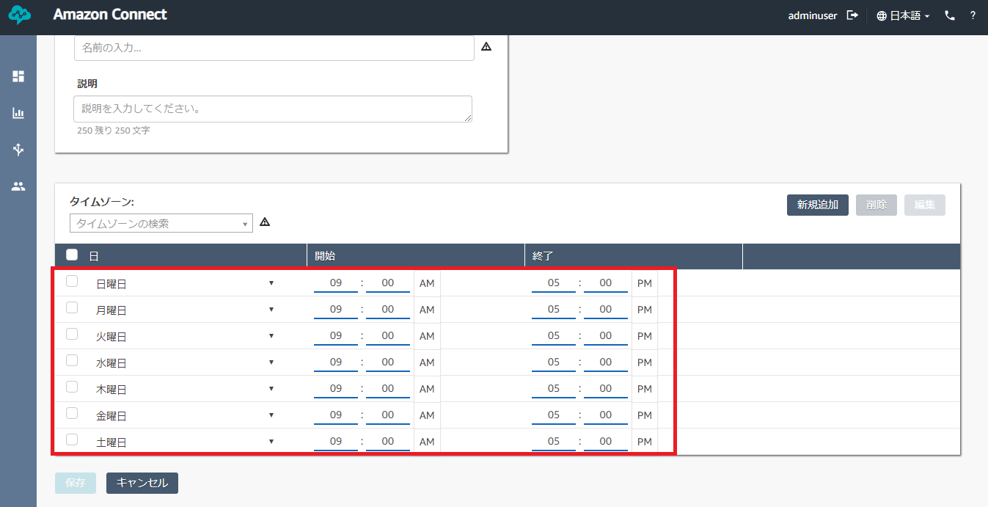

Figure 19. Hours of Operation Days Scope

* You can change the day by clicking on the dropdown and choosing among the options.

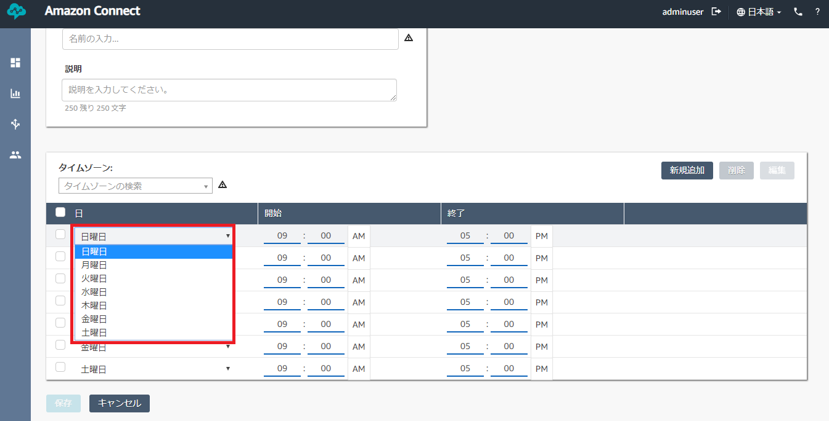

Figure 20. Days Dropdown List

* To remove a certain day, tick the checkbox beside the day. Then, click “Remove”. It will immediately remove the day without any confirmation.

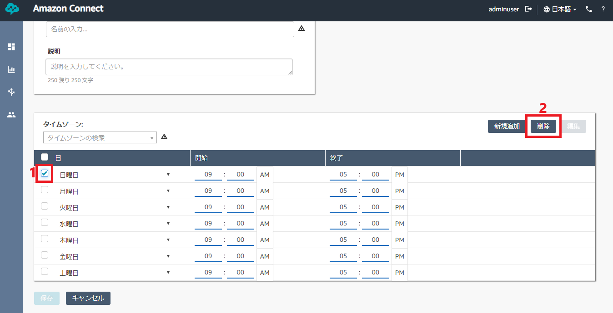

Figure 21. Steps in Removing a Day

* If you want to add a day, click on “Add new” button.

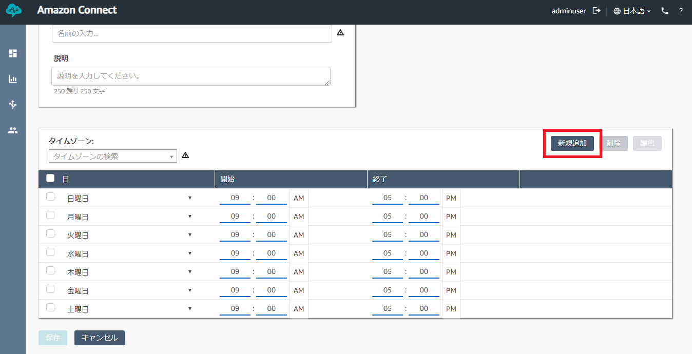

Figure 22. Adding New Day

* Click “Save” to complete creation of Hours of Operation.

## **Editing Hours of Operation**

* To edit an hour of operation, click on the name of Hours of Operation.

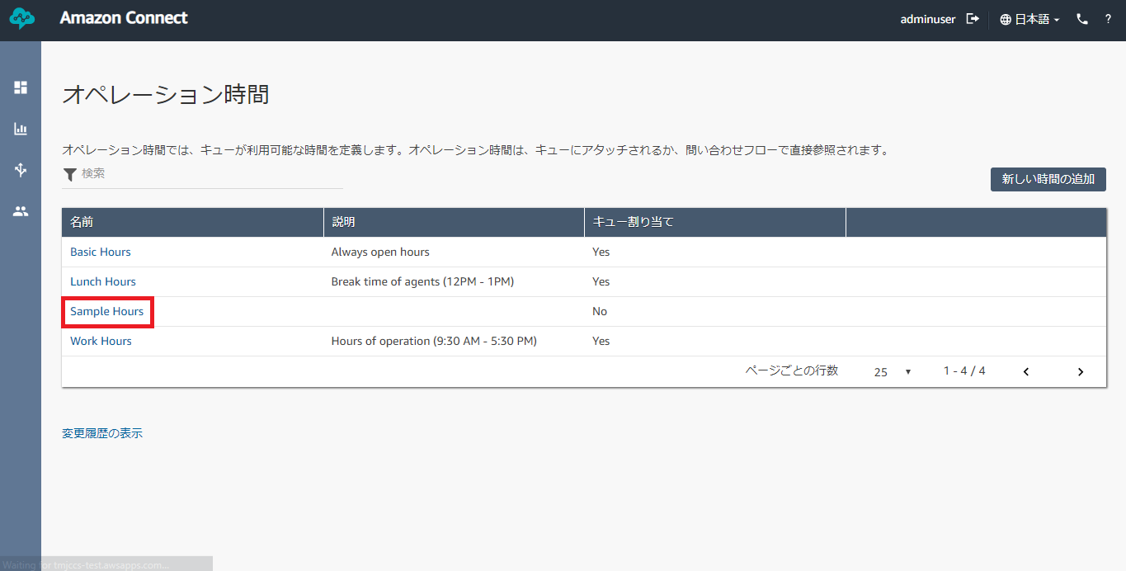

Figure 23. Editing Hours of Operation

* Modify the name for the hours of operation by changing the name.



Figure 24. Hour of Operation Creation Form

* Then choose a Time zone. For Japan, you can choose “Asia/Tokyo” among the dropdown list.



Figure 25. Hours of Operation Time Zone

* Change the time according to your preferred hours. Toggle AM and PM by clicking on them.



Figure 26. Hours of Operation Days Scope

* You can change the day by clicking on the dropdown and choosing among the options.



Figure 27. Days Dropdown List

* To remove a certain day, tick the checkbox beside the day. Then, click “Remove”. It will immediately remove the day without any confirmation.



Figure 38. Steps in Removing a Day

* If you want to add a day, click on “Add new” button.



Figure 29. Adding New Day

* Click “Save” to confirm changes in Hours of Operation.

# **Queue**

## **Creating a Queue**

*Note: As of now, Queue* ***cannot be deleted****. Amazon hasn’t implemented the function yet. Be careful of creating new Queues. Alternatively, you can modify existing queues to suit your preference.*

***Prerequisites:***

1. *Hours of Operation*
2. *Phone Number (optional)*
3. *Quick Connects (optional)*

* Hover over the third icon in the left navigation bar and click on “Queues”.

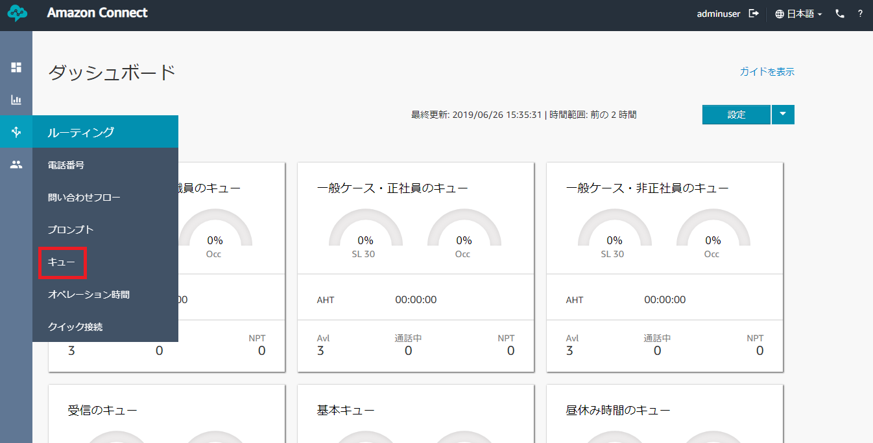

Figure 30. Queue Link on Routing

* Clicking the blue “Add new queue” button will send you to the queue creation form.

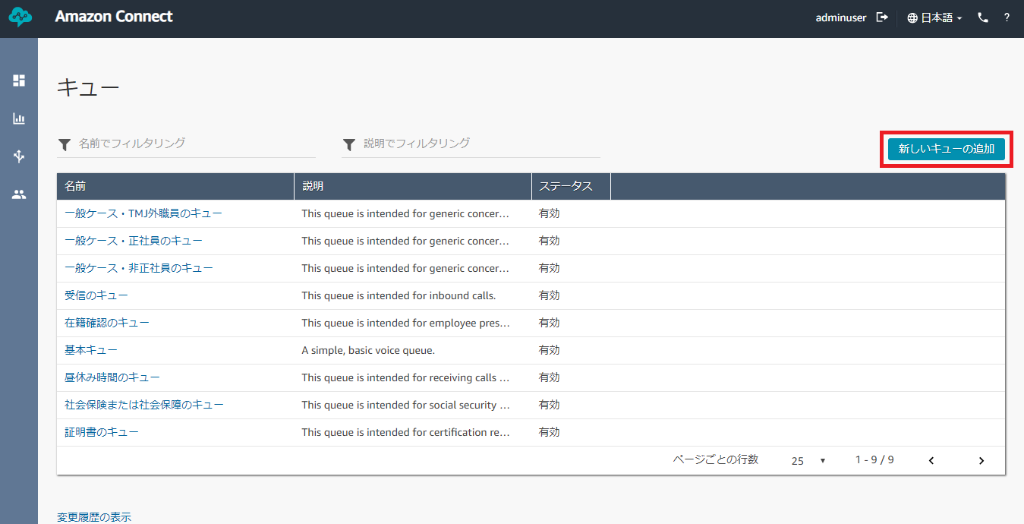

Figure 31. Adding New Queue

* Specify a name for your queue.

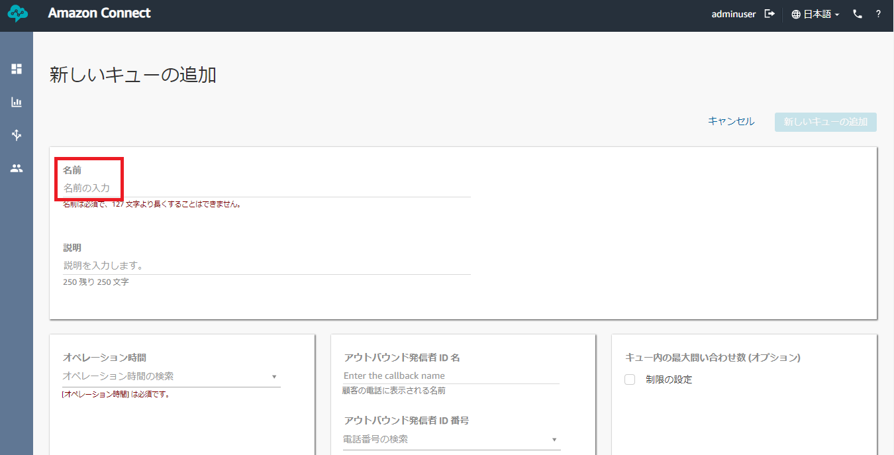

Figure 32. Queue Name

* Click on the Hours of Operation dropdown and choose among the hours in the list. The queue will only function within the specified hour of operation.

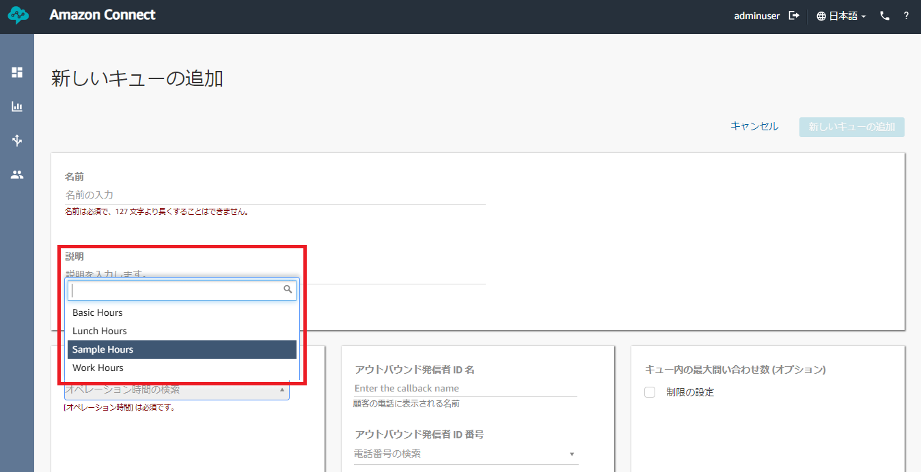

Figure 33. Hours of Operation of a Queue

* You can also configure other optional settings in the queue.
  + You can add a description to your queue.
  + An Outbound Caller ID Name is the name that will show up on the receiver’s phone when the number specified in the queue make an outbound call.
  + An Outbound Caller ID Number is the number that will be used to make it possible to do an outbound call. It will also be the number that the receiver will see on their phone.
  + An Outbound Whisper Flow is the whisper contact flow that will be activated when making an outbound call. It is very seldomly used.
  + Maximum Contacts in Queue is the maximum limit that a queue can hold.
  + Quick Connects is the list of Quick Connects that will appear on the CCP when doing Transfer calls.
* Click “Save” to confirm the queue creation.

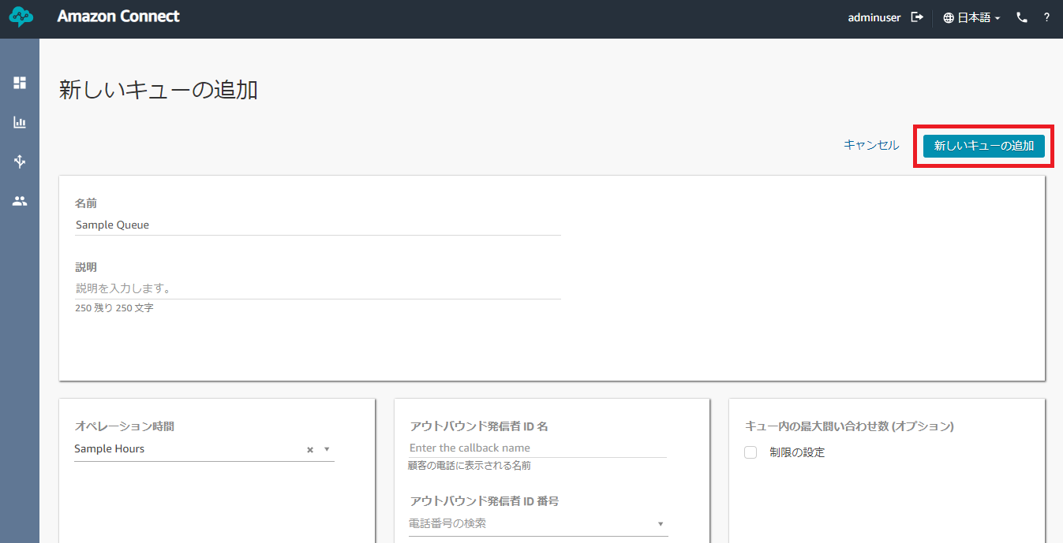

Figure 34. Saving Queue Creation

## **Editing a Queue**

* Click on the name of the queue to edit it.

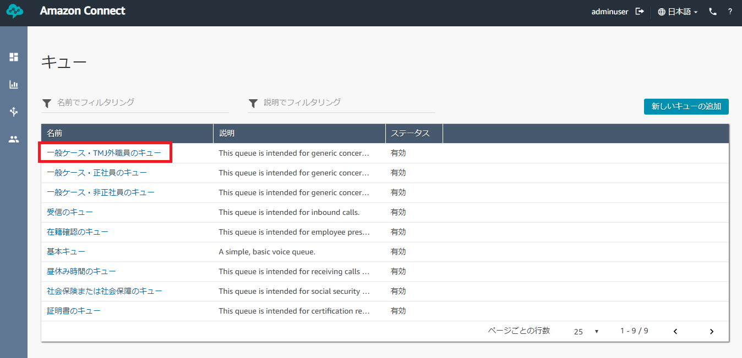

Figure 35. Editing a Queue

* Change the name of the queue.



Figure 36. Queue Name

* Click on the Hours of Operation dropdown and choose among the hours in the list. The queue will only function within the specified hour of operation.



Figure 37. Hours of Operation of a Queue

* You can also configure other optional settings in the queue.
  + You can add a description to your queue.
  + An Outbound Caller ID Name is the name that will show up on the receiver’s phone when the number specified in the queue make an outbound call.
  + An Outbound Caller ID Number is the number that will be used to make it possible to do an outbound call. It will also be the number that the receiver will see on their phone.
  + An Outbound Whisper Flow is the whisper contact flow that will be activated when making an outbound call. It is very seldomly used.
  + Maximum Contacts in Queue is the maximum limit that a queue can hold.
  + Quick Connects is the list of Quick Connects that will appear on the CCP when doing Transfer calls.
* Click “Save” to confirm the changes in queue.



Figure 38. Saving Changes in Queue

## **Disabling a Queue**

* You can disable a queue when it is not in use. For now, this is the most efficient method of removing your queue from the system temporarily. Hover over the queue name and a Power  icon will appear. Click the icon to disable the queue. You can enable it using the same process.

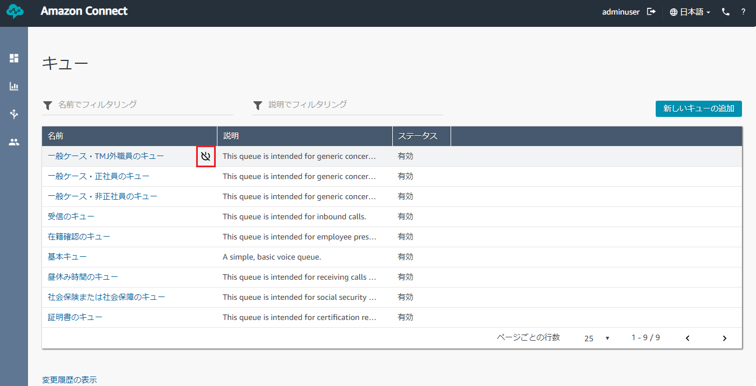

Figure 39. Power Icon Beside Queue Name to Enable/Disable

# **Routing Profile**

## **Creating a Routing Profile**

*Note: As of now, Routing Profile* ***cannot be deleted****. Amazon hasn’t implemented the function yet. Be careful of creating new Routing Profiles. Alternatively, you can modify existing routing profiles to suit your preference.*

***Prerequisites:***

1. *Queue*

* Hover over the fourth icon in the left navigation bar and click on “Routing Profiles”.

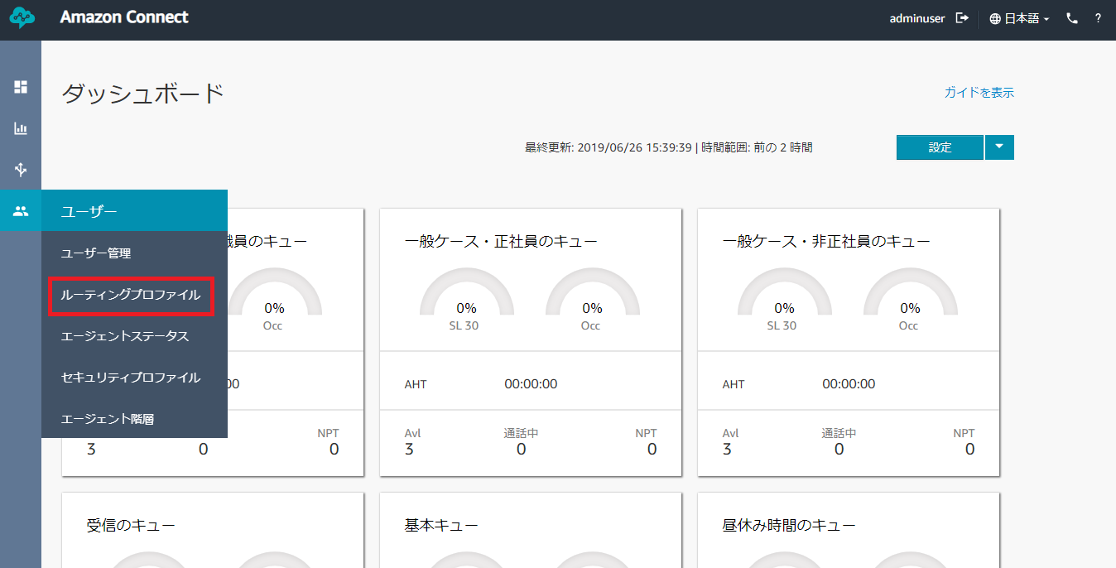

Figure 40. Routing Profile Link in Users

* Click the blue “Add new profile” button on the upper-right corner of the page. You will be sent to the routing profile creation form.

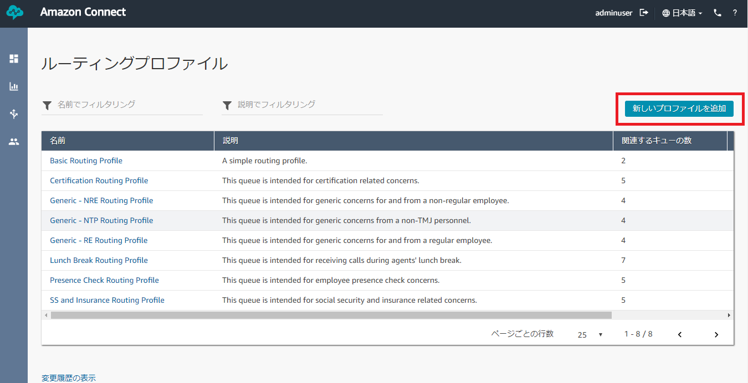

Figure 41. Add New Profile Button

* Add the name and the description for your routing profile. These are required.

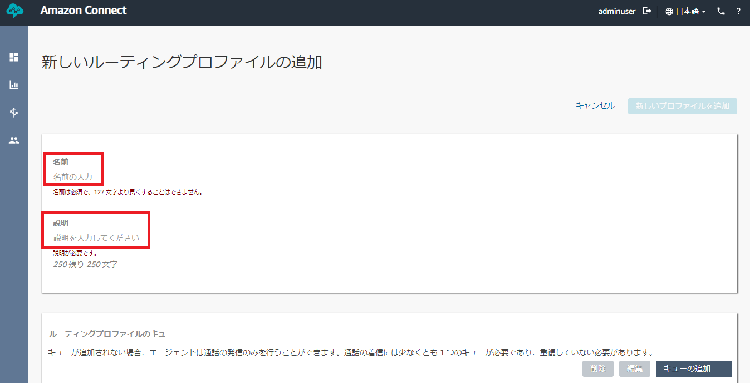

Figure 42. Routing Profile Name and Description

* You can also add a queue to your routing profile in order for the agents assigned in this routing profile to be able to receive calls. Not doing so will only let the agents do outbound calls. To add one, choose among the list of queues in the dropdown and add preferred priority and delay.
  + Priority – this is the order in which contacts are handled by the queue they are in. Set values in order of importance, with the lowest number equaling the highest priority. For example, a contact in a queue with a priority of 2 would be a lower priority than a contact in a queue with a priority of 1.
  + Delay (in seconds) – this is the minimum queue time before the call is routed to an agent with a matching queue.

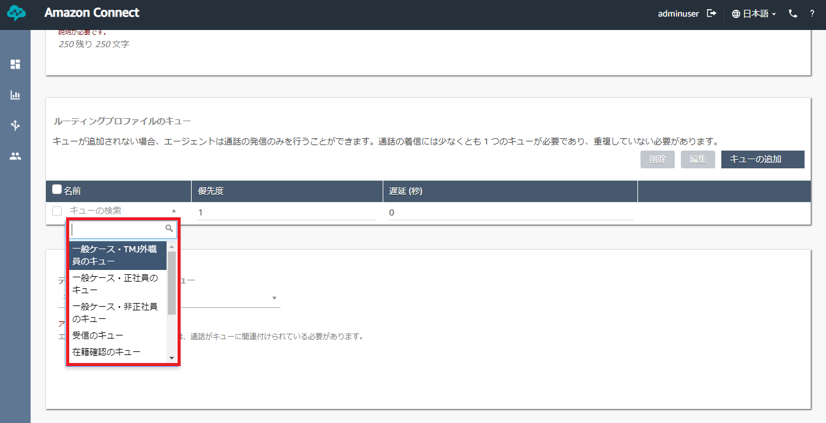

Figure 43. Queue Dropdown in Routing Profile Form

* + Adding a Queue – click on the “Add queue” button to confirm adding the queue in the routing profile. You can add more than one queue in the routing profile.

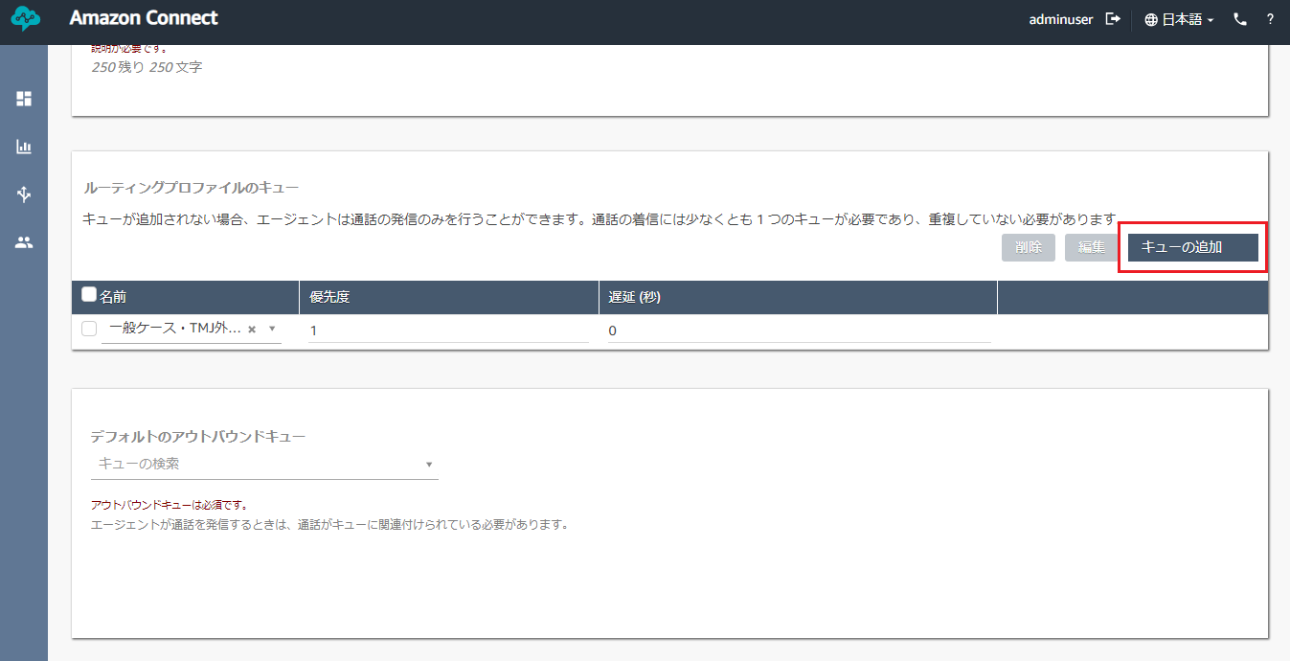

Figure 44. Adding Queue to a Routing Profile

* + Editing a Queue – tick the checkbox beside the chosen queue name and click on the “Edit” button. Proceed to make changes in the queue, priority and delay. Press “Done” to confirm the changes.

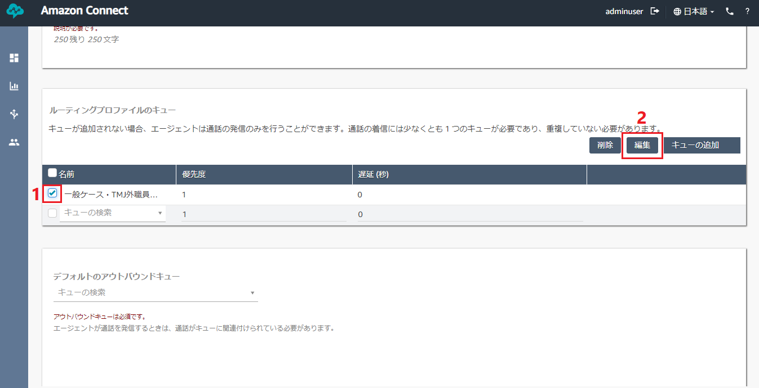

Figure 45. Steps in Editing a Queue in Routing Profile

* + Removing a Queue – tick the checkbox beside the chosen queue name and click on the “Remove” button. Confirm the deletion by clicking on the red “Remove” button in the model that will appear.

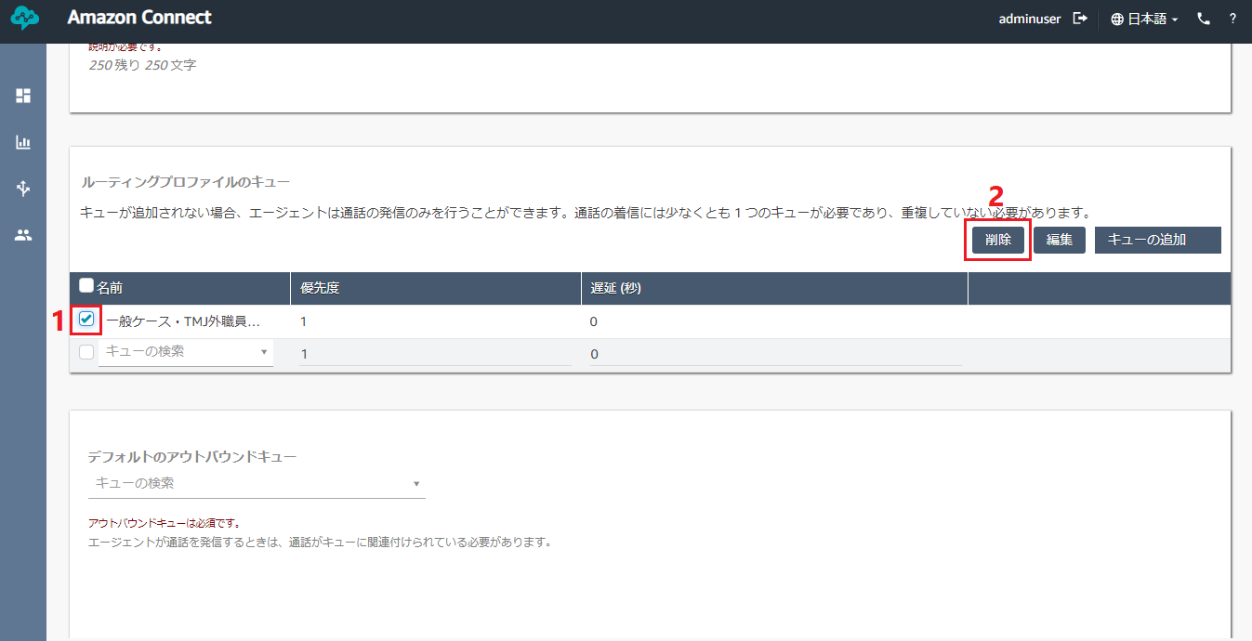

Figure 46. Steps in Removing a Queue from Routing Profile

* Lastly, you need to add a queue from the queue list in the Default Outbound Queue dropdown. This will associate the queue with the agent when doing an outbound call.

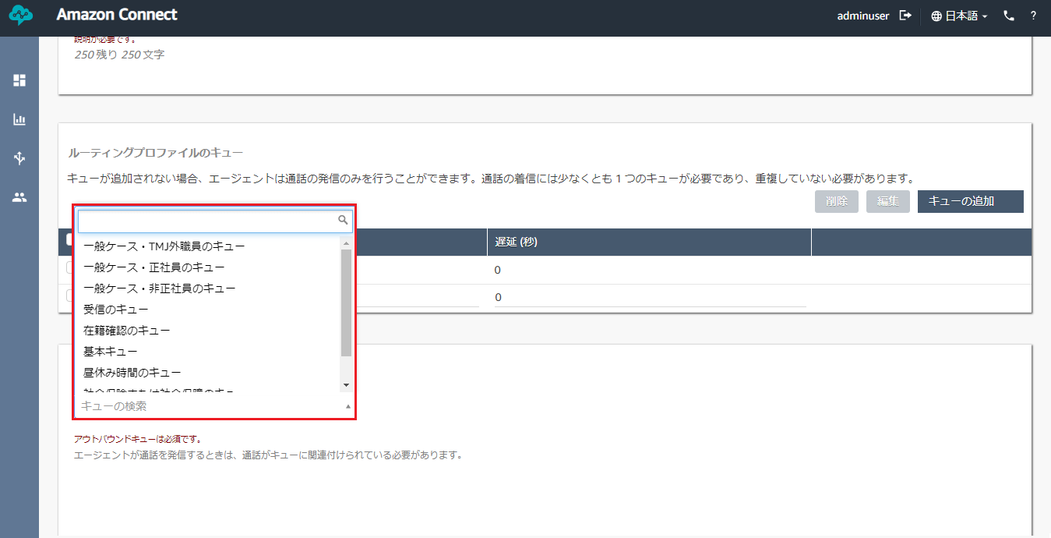

Figure 47. Default Outbound Queue Dropdown List

* Save the creation of the routing profile by clicking the “Add new profile” button.

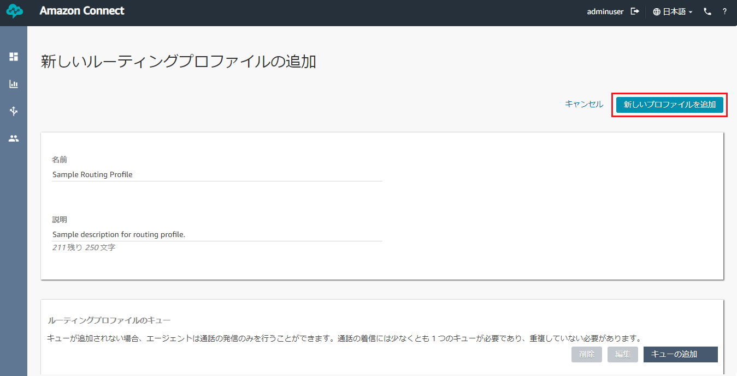

Figure 48. Creating Routing Profile Confirmation

## **Editing a Routing Profile**

* To edit a routing profile, you need to click on the specified routing profile name.

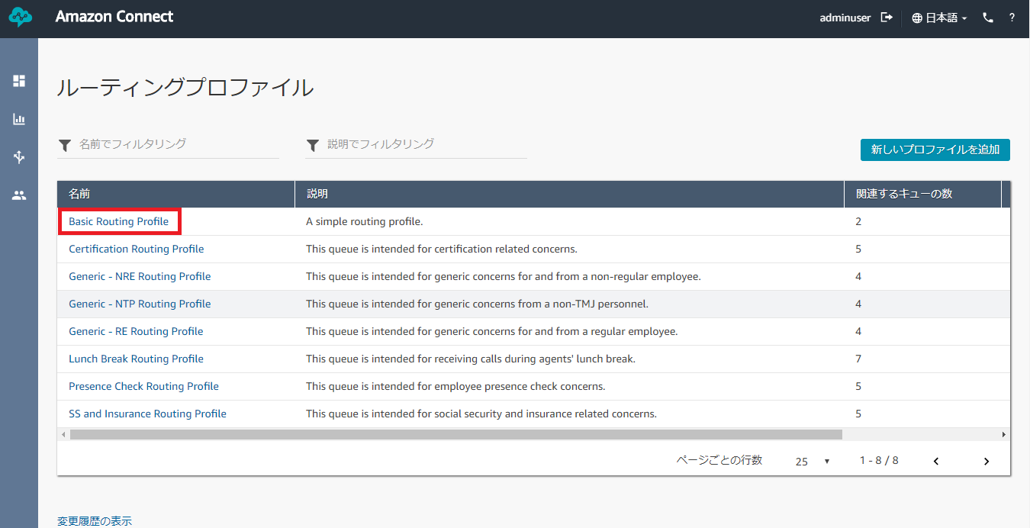

Figure 49. Editing Routing Profile

* You can change the name and the description for your routing profile.



Figure 42. Routing Profile Name and Description

* You can also edit the queue to your routing profile. To add one, choose among the list of queues in the dropdown and add preferred priority and delay.
  + Priority – this is the order in which contacts are handled by the queue they are in. Set values in order of importance, with the lowest number equaling the highest priority. For example, a contact in a queue with a priority of 2 would be a lower priority than a contact in a queue with a priority of 1.
  + Delay (in seconds) – this is the minimum queue time before the call is routed to an agent with a matching queue.



Figure 43. Queue Dropdown in Routing Profile Form

* + Adding a Queue – click on the “Add queue” button to confirm adding the queue in the routing profile. You can add more than one queue in the routing profile.



Figure 44. Adding Queue to a Routing Profile

* + Editing a Queue – tick the checkbox beside the chosen queue name and click on the “Edit” button. Proceed to make changes in the queue, priority and delay. Press “Done” to confirm the changes.



Figure 45. Steps in Editing a Queue in Routing Profile

* + Removing a Queue – tick the checkbox beside the chosen queue name and click on the “Remove” button. Confirm the deletion by clicking on the red “Remove” button in the model that will appear.



Figure 46. Steps in Removing a Queue from Routing Profile

* Lastly, you need can change the queue from the queue list in the Default Outbound Queue dropdown. This will associate the queue with the agent when doing an outbound call.



Figure 47. Default Outbound Queue Dropdown List

* Save the changes in the routing profile by clicking the “Save” button.



Figure 48. Creating Routing Profile Confirmation

# **User**

## **Creating a User**

***Prerequisites:***

1. *Routing Profile*

* Hover over the fourth icon in the left navigation bar and click on “User Management”.

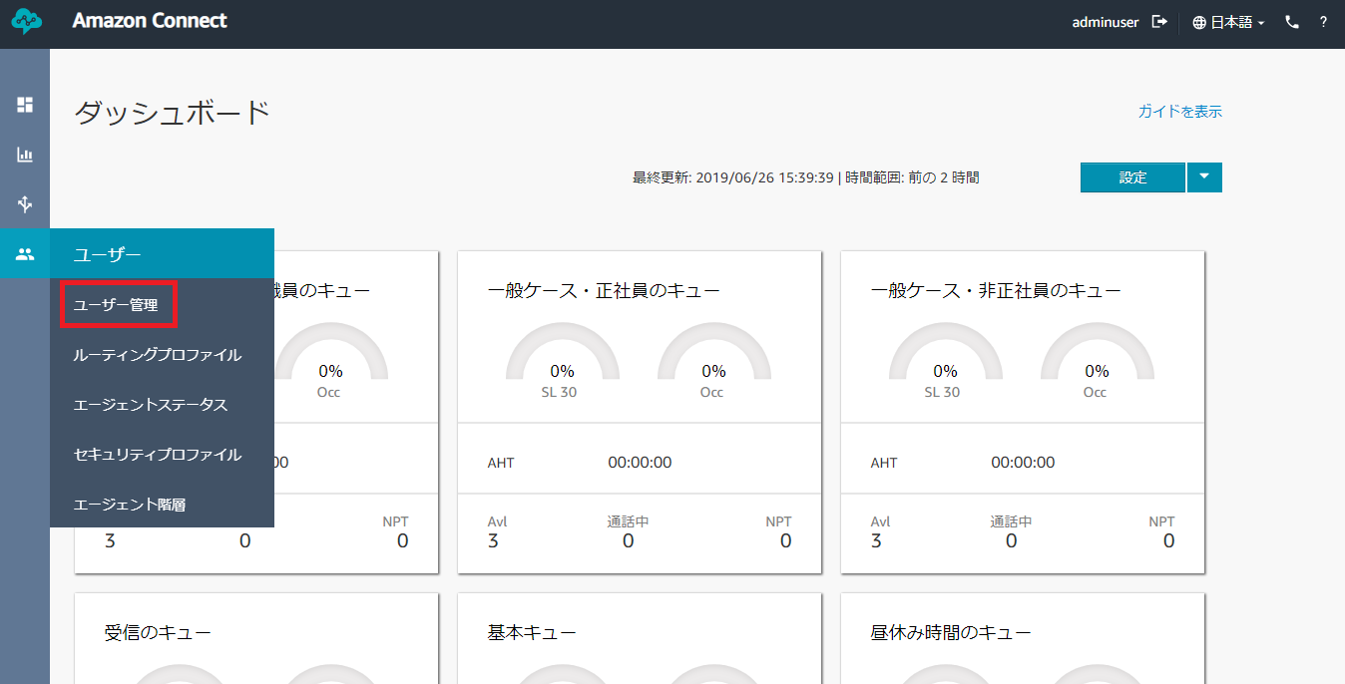

Figure 49. User Management Link in Users

* Click on the blue “Add new users” button.

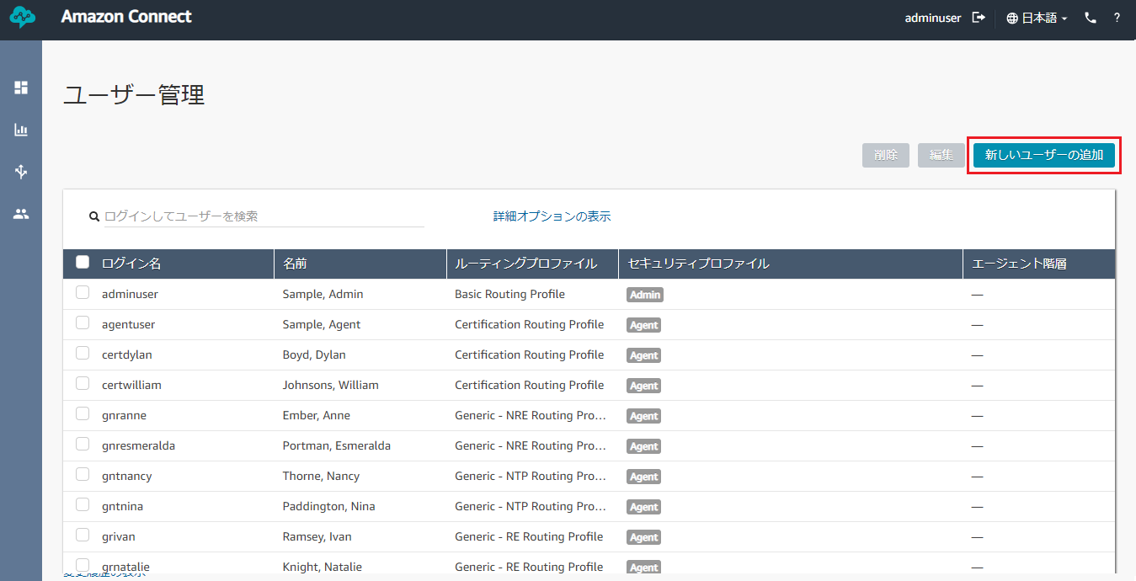

Figure 50. Adding New User

* Choose “Create and set up a new user” and click the blue “Next” button.

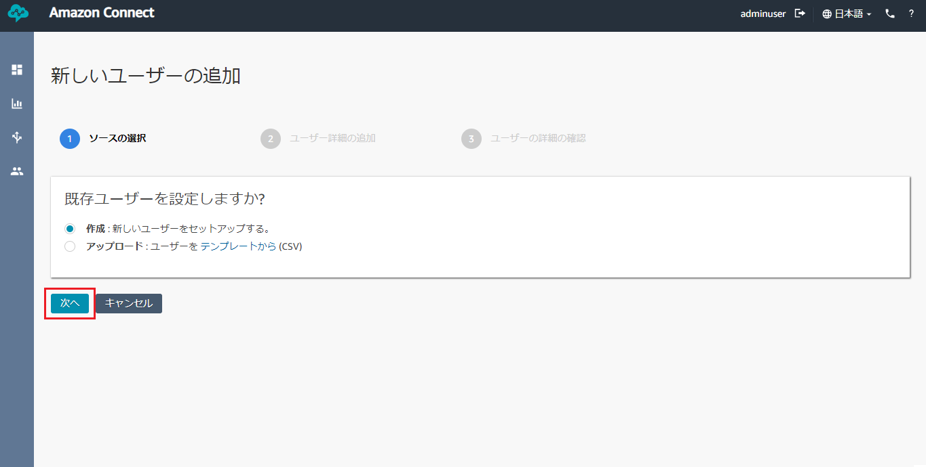

Figure 51. Choosing How to Create a User

* Fill out the basic information for the user you will be creating: first name, last name, username, email address, password and password verification. A username must not be more than 20 characters. A password must be 8 characters or more with at least one uppercase letter, one lowercase letter and one number.

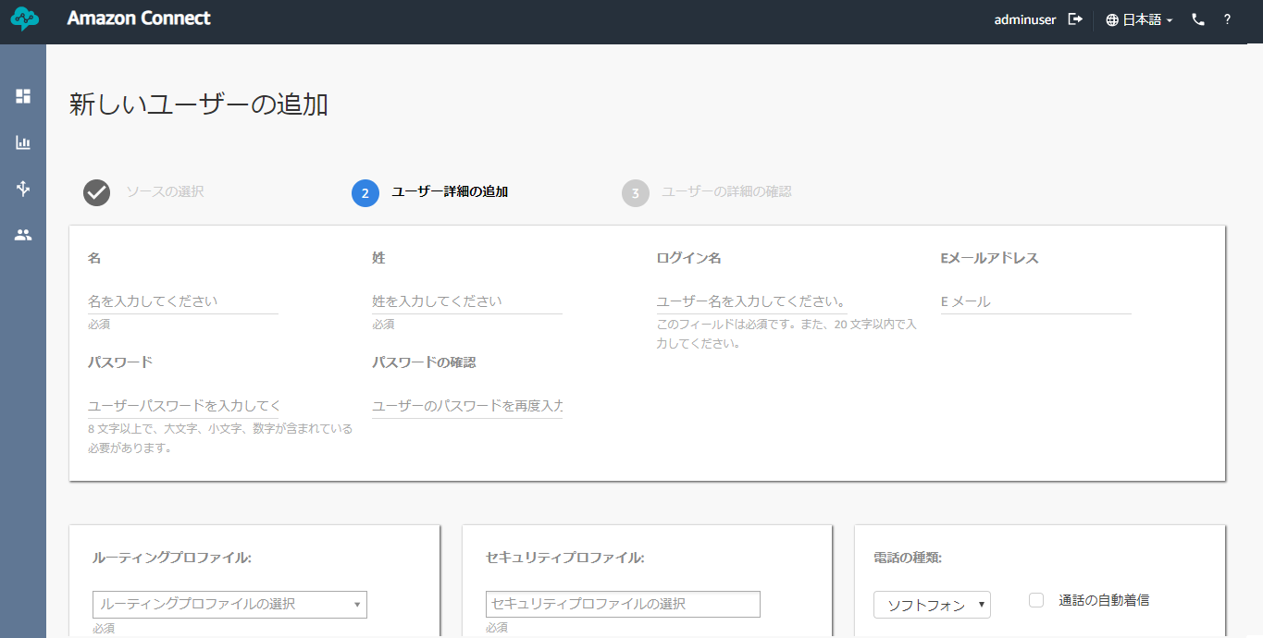

Figure 52. User Creation Basic Info Form

* Select among the options in the dropdown lists of Routing and Security Profile.
  + Routing Profile – the routing profile that the user will be following.
  + Security Profile – the access and permission to be granted to the user.
  + Phone Type – the type of phone the user will use. Soft phone is the CCP. If you choose Desk phone, you should specify the device’s phone number which will be used by the user.
  + Auto-Accept Call – tick the checkbox if you want the user to accept incoming calls automatically.
  + After Call Work (ACW) Timeout – this specifies how many seconds it will take for the next call in the queue to be received.

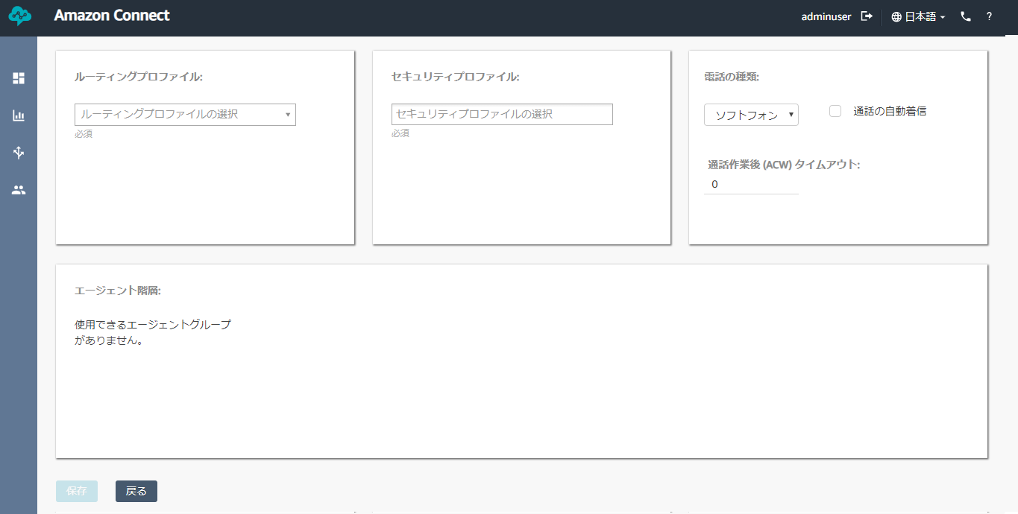

Figure 53. User Creation Configuration Form

* Click the blue “Save” button to proceed.
* Finally, click “Create users” to confirm creation.

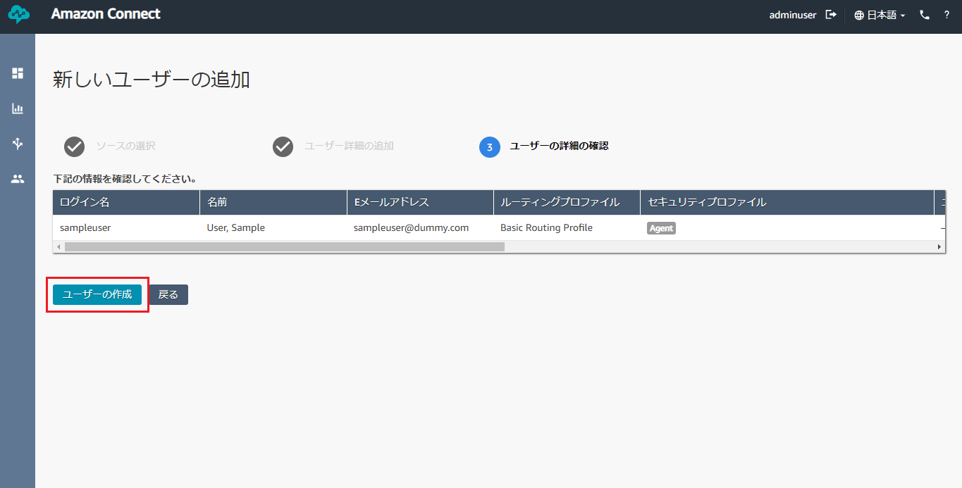

Figure 54. User Confirmation Page

* Wait for the status to be “Done” to make sure the user has been created. If you want to create another user, click on “Create more users”. Or click “Back” to go back to the Users list.

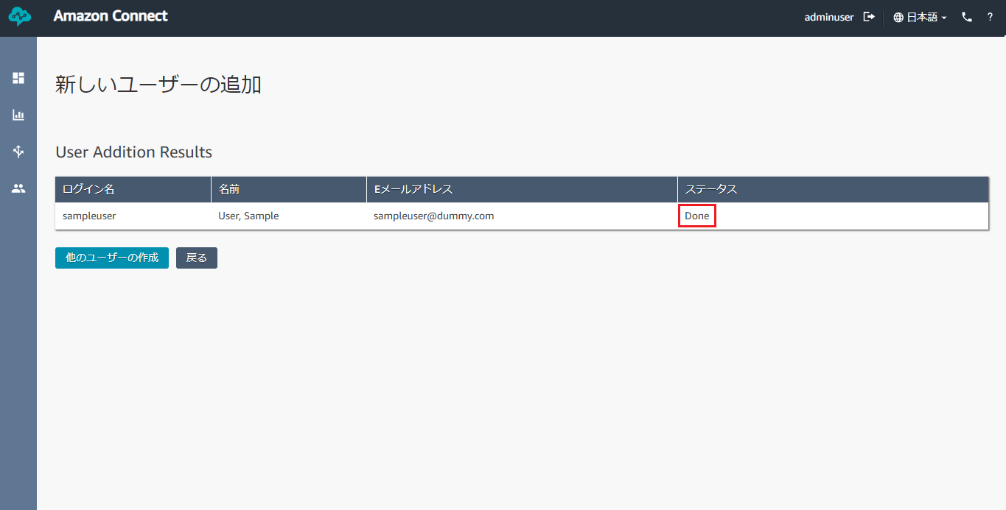

Figure 55. User Created Page

## **Editing a User**

* To edit a user, tick the checkbox beside the user and click “Edit”.

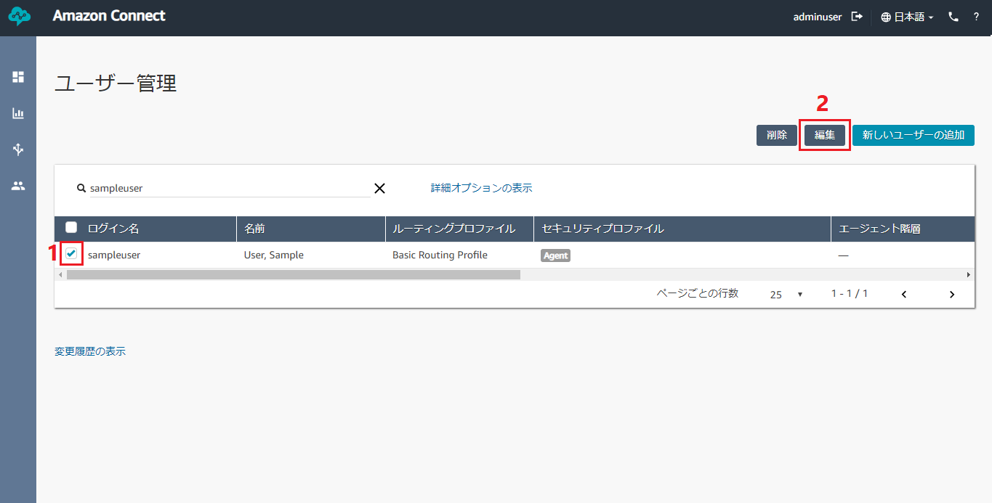

Figure 56. Steps to Edit a User

* You will be brought to the User Edit page where you can modify some information about the user:
  + Email Address
  + Password – resetting a password will send a confirmation to the user’s email.
  + Routing Profile – the routing profile that the user will be following.
  + Security Profile – the access and permission to be granted to the user.
  + Phone Type – the type of phone the user will use. Soft phone is the CCP. If you choose Desk phone, you should specify the device’s phone number which will be used by the user.
  + Auto-Accept Call – tick the checkbox if you want the user to accept incoming calls automatically.
  + After Call Work (ACW) Timeout – this specifies how many seconds it will take for the next call in the queue to be received.

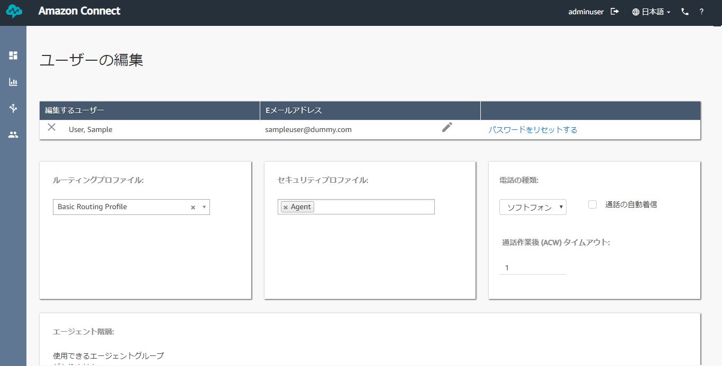

Figure 57. User Edit Form

* Click the “Save” button to save the changes.

## **Removing a User**

* To remove a user, tick the checkbox beside the user and click “Remove”.

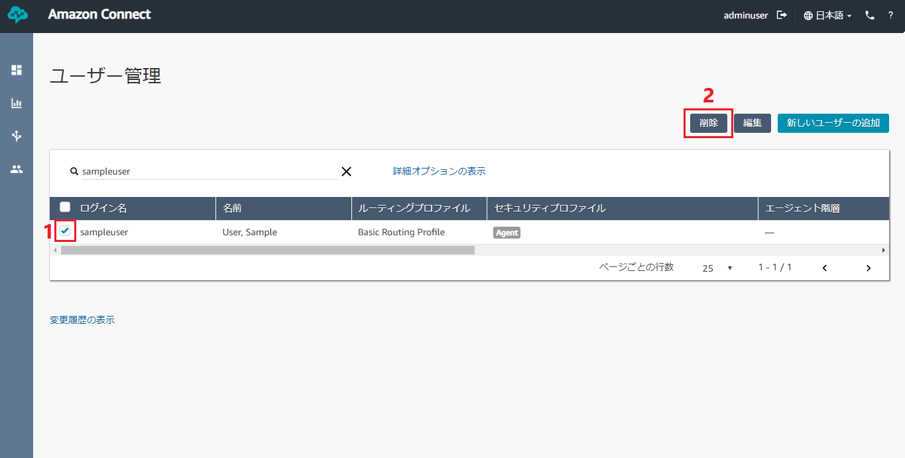

Figure 58. Steps to Remove a User

* Click “Remove” in the modal to confirm the deletion. This action is irreversible.

# **Quick Connects**

## **Creating a Quick Connect**

*Note: As of now, Quick Connects* ***cannot be deleted****. Amazon hasn’t implemented the function yet. Be careful of creating new Quick Connects. Alternatively, you can modify existing quick connects to suit your preference.*

***Prerequisites:***

1. *For Quick Connect to Agent (User and Contact Flow)*
2. *For Quick Connect to Queue (Queue and Contact Flow)*
3. *For Quick Connect to External (None)*

* Hover over the third icon in the left navigation bar and click on “Quick Connects”.

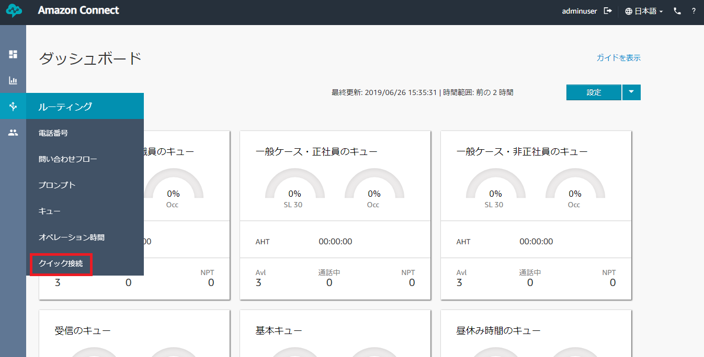

Figure 59. Quick Connects Link in Users

* Click on the blue “Add new” button to add a blank list of quick connect you can fill out.

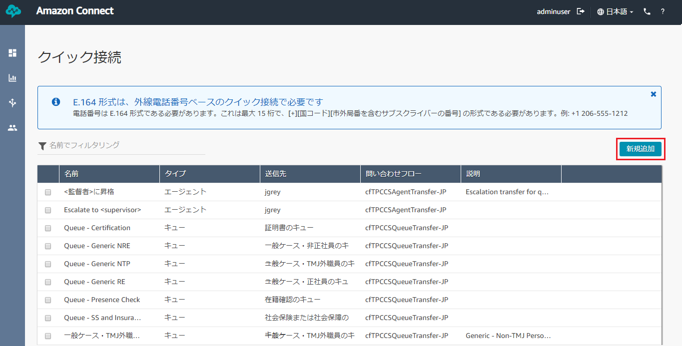

Figure 60. Adding New Quick Connects

* Add the name and description of the Quick Connect.

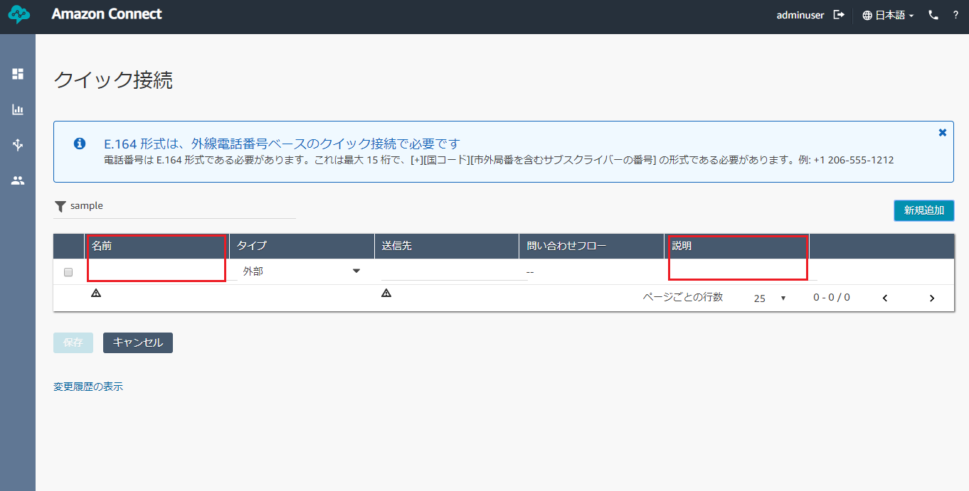

Figure 61. Quick Connect Name and Description

* Choose the Type of Quick Connect, each one needing different requirements:

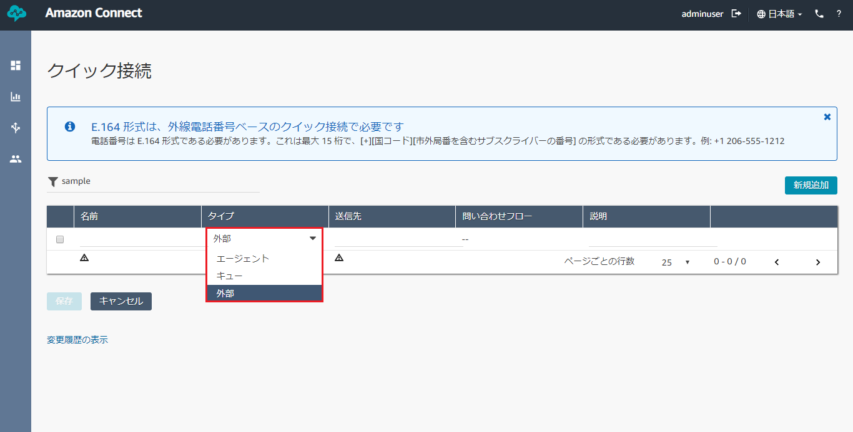

Figure 62. Type of Quick Connect Dropdown

* + Agent Type – choose a user from the Destination dropdown list whom the call will be transferred to. Choose a Transfer to Agent Flow in the Contact Flow dropdown list. This is the flow that the quick connect will be using upon transfer of the call.

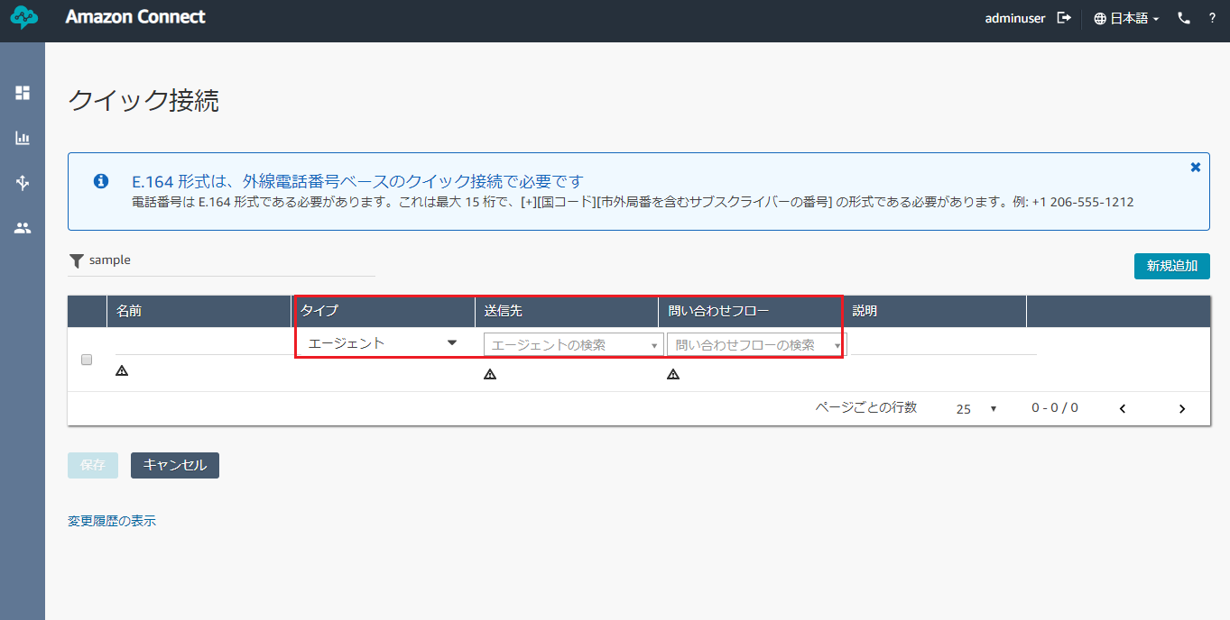

Figure 63. Agent Type Quick Connect Requirements

* + Queue Type – choose a queue from the Destination dropdown list in which the call will be transferred to. Choose a Transfer to Queue Flow in the Contact Flow dropdown list. This is the flow that the quick connect will be using upon transfer of the call.

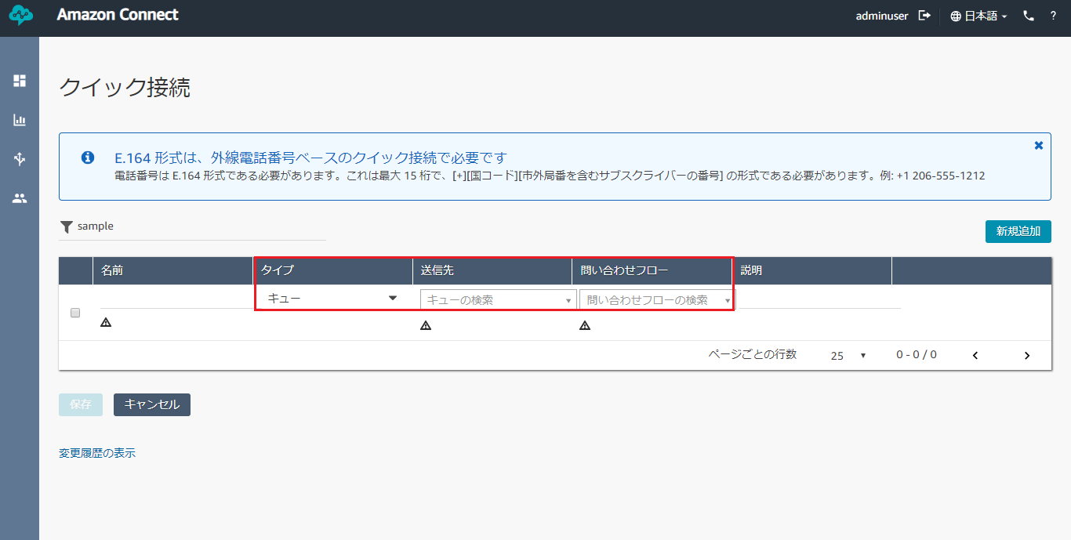

Figure 64. Queue Type Quick Connect Requirements

* + External Type – this requires a phone number as the Destination.

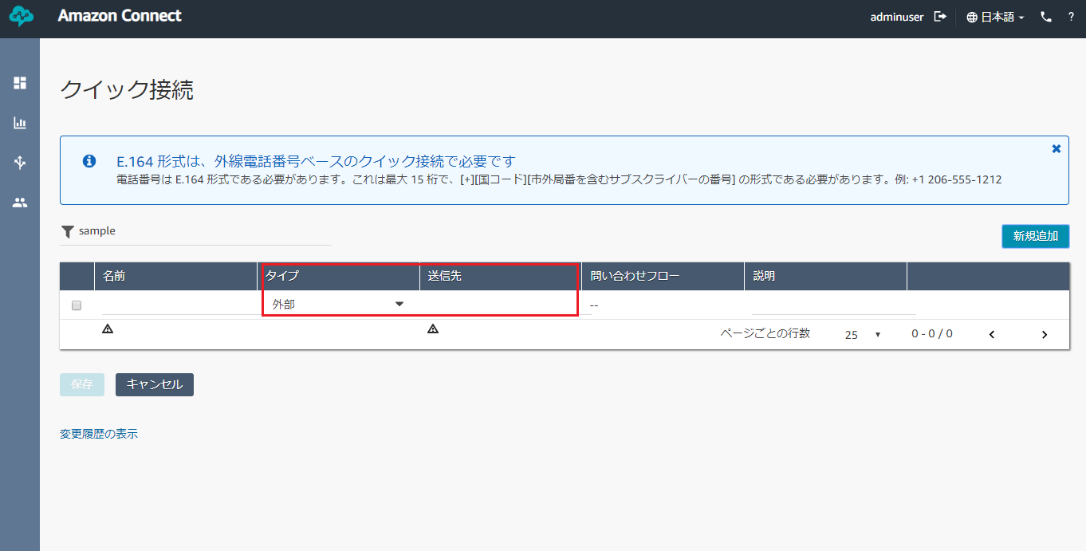

Figure 65. External Type Quick Connect Requirements

* Click “Save” to officially add the Quick Connect to the list.

## **Editing a Quick Connect**

* To edit a Quick Connect, just click anywhere in the quick connect you want to modify.

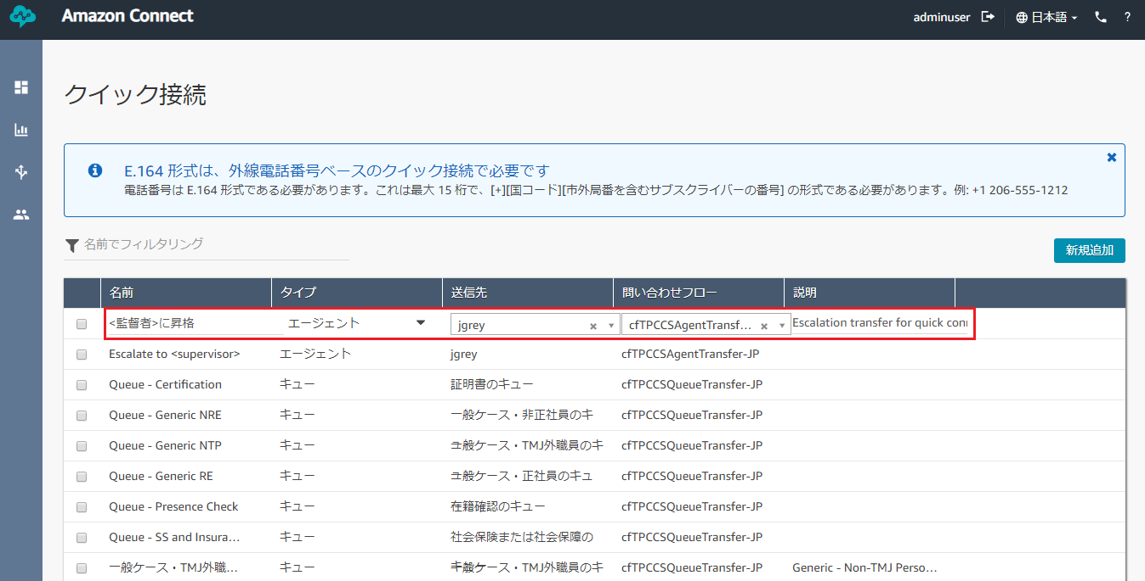

Figure 66. Editing Quick Connects

* Make the changes and click “Save” to save the changes. You can edit multiple quick connects all at once. Clicking “Save” will save all the changes from each of them.

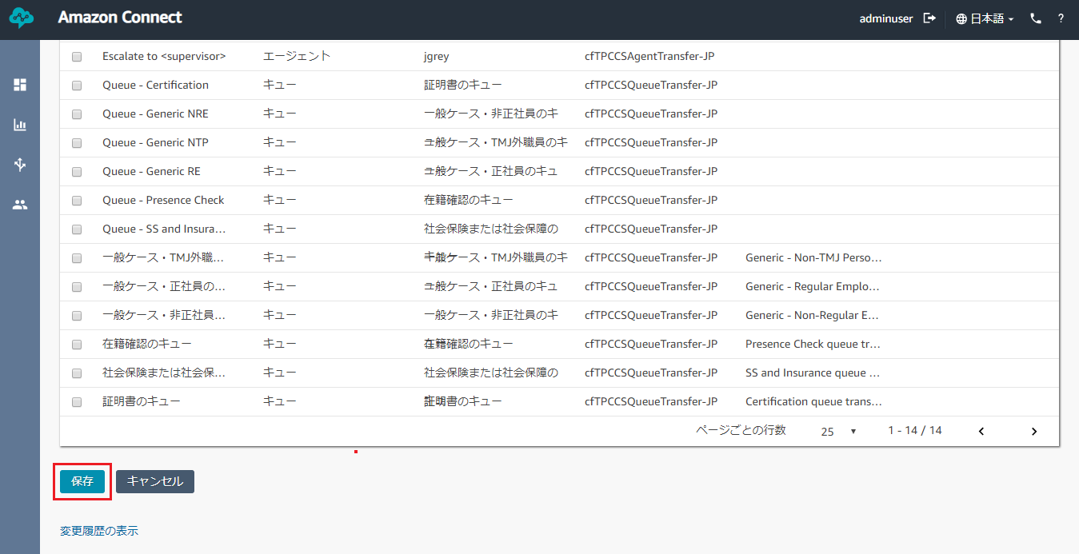

Figure 67. Saving Quick Connects

# **Real-Time Metrics**

## **Checking Agents’ Real-Time Metrics**

* Hover over the second icon in the left navigation bar and click on “Real-time metrics”.

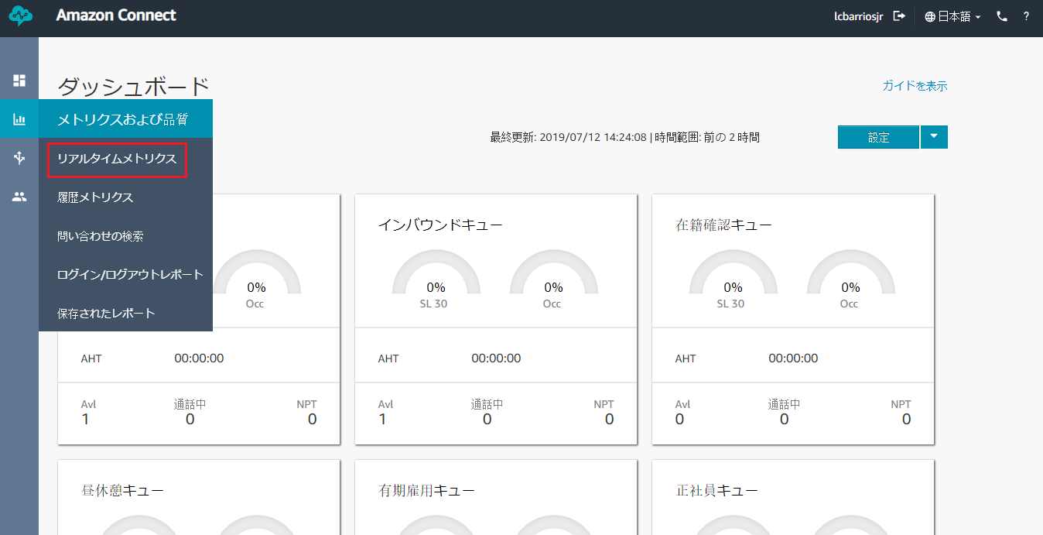

Figure 68. Real-time metrics Link in Metrics and quality

* Click on “Agents” to view the status and metrics for logged-in agents.

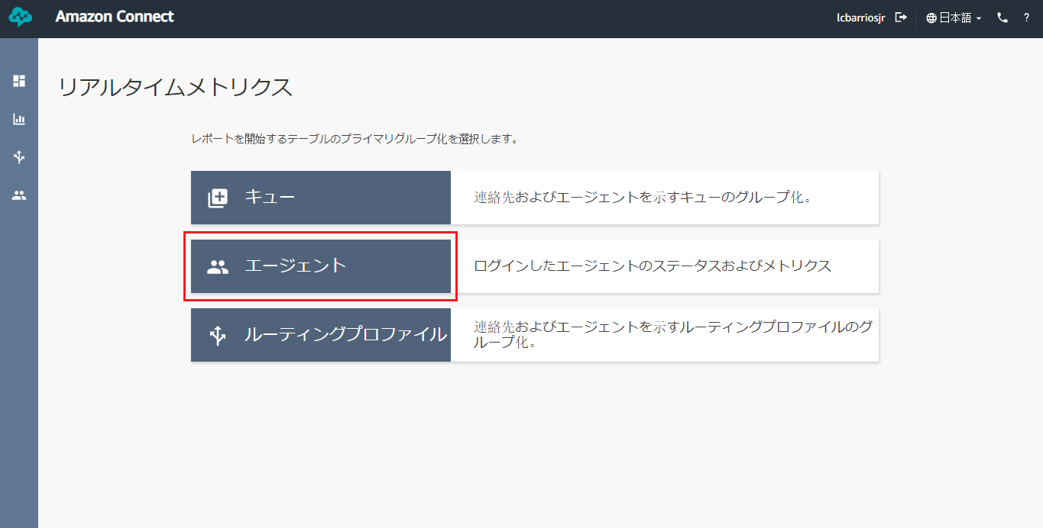

Figure 69. Real-time Metrics for Agents button

* Scroll left or right to view more information about the metrics of each agents. This page is being refreshed every 15 seconds. There are multiple metrics that is being monitored in this page:

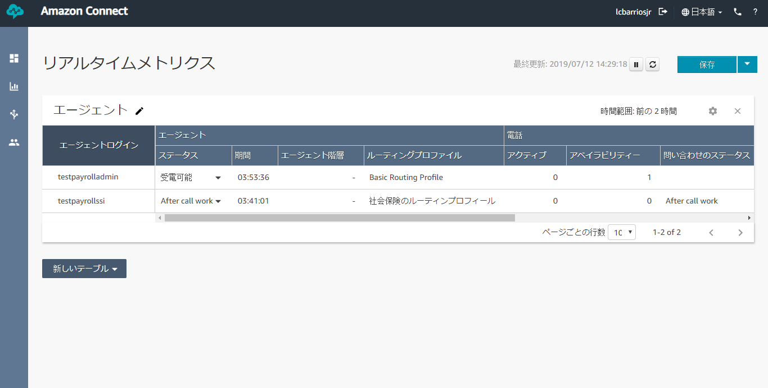

Figure 70.Real-time Metrics for Agents table

* + Status – the current status of the agent. Possible values include *Available* and *AfterCallWork*.
  + Duration – amount of time that the agent has been in the current status.
  + Agent Hierarchy – the hierarchy the agent is assigned to, if any.
  + Routing Profile – the routing profile for the agent.
  + Active – indicates whether the agent is currently active on a contact. The value is 1 (true) or 0 (false).
  + Availability – indicates whether the agent is currently in the Available status. The value is 1 (true) or 0 (false).
  + Contact State – the state of the most recent contact the agent handled.
  + Queue – the name of the queue associated with the most recent contact the agent handled.
  + Avg ACW (Average After Call Work) – average time, in seconds, that an agent spent in the *AfterCallWork* status during the specified time range.
  + Missed – count of contacts routed to an agent but not answered by the agent, including contacts abandoned by the customer, during the specified time range. A contact can be counted as missed multiple times, once for each time it is routed to an agent but not answered.
  + Handled in – count of incoming contacts handled by an agent during the specified time range that were initiated using one of the following methods: inbound call, transfer to agent, transfer to queue, or queue-to-queue transfer.
  + Handled out – count of contacts handled by an agent during the specified time range that were initiated by an agent placing an outbound call using the CCP.
  + AHT (Average Handled Time) – average time, from start to finish, that a contact was connected with an agent. This is calculated by averaging the amount of time between the contact being answered by an agent and the contact ending.
  + Occupancy – percentage of time the agent was active on contacts during the specified time range.

## **Saving Real-Time Metrics**

* To save a metrics table, click the blue “Save” button on the upper-right corner of the page.

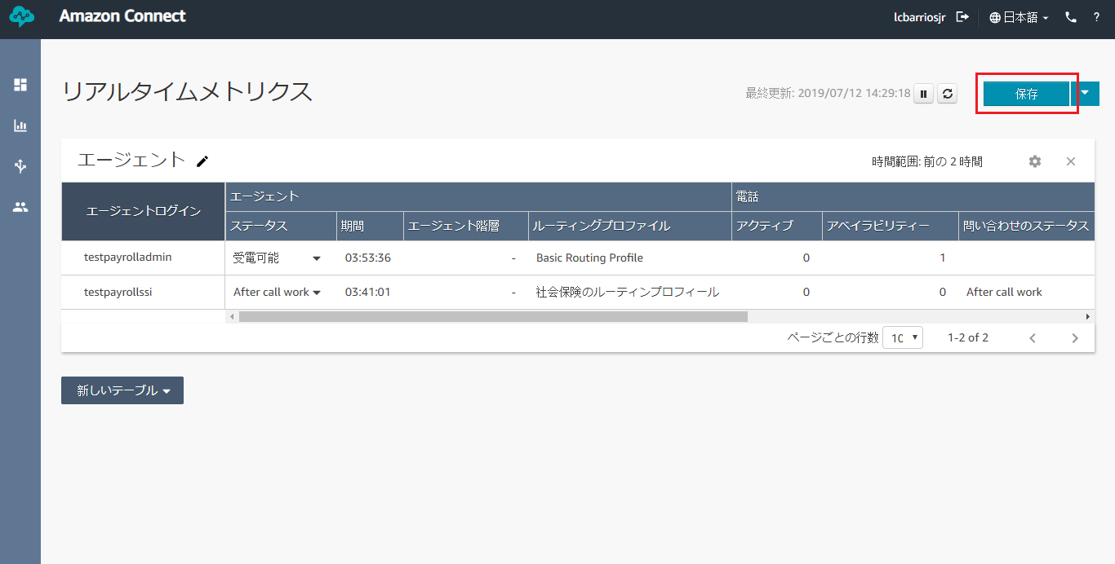

Figure 71. Saving Real-time Metrics

* Provide a name for the metrics and click “Save”.

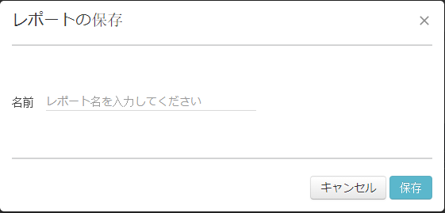

Figure 72. Real-time Metrics Save Modal

* Hover over the second icon in the left navigation bar and click on “Saved reports”.

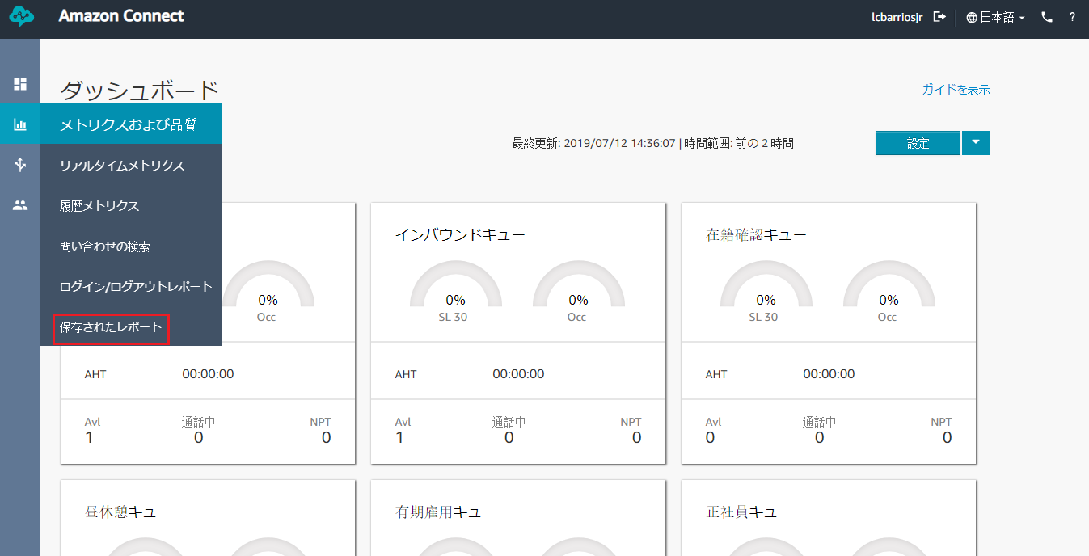

Figure 73. Saved reports Link in Metrics and quality

* Click on the name of the metrics you created to view the metrics table.

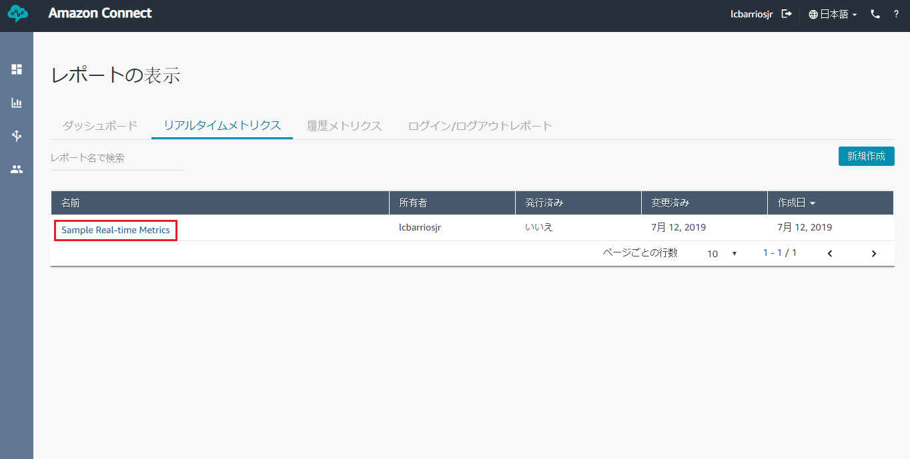

Figure 74. Viewing Saved Real-time Metrics

* To delete the saved metrics, hover over the metrics name and click the trash can icon. Then, click “Delete” to confirm.

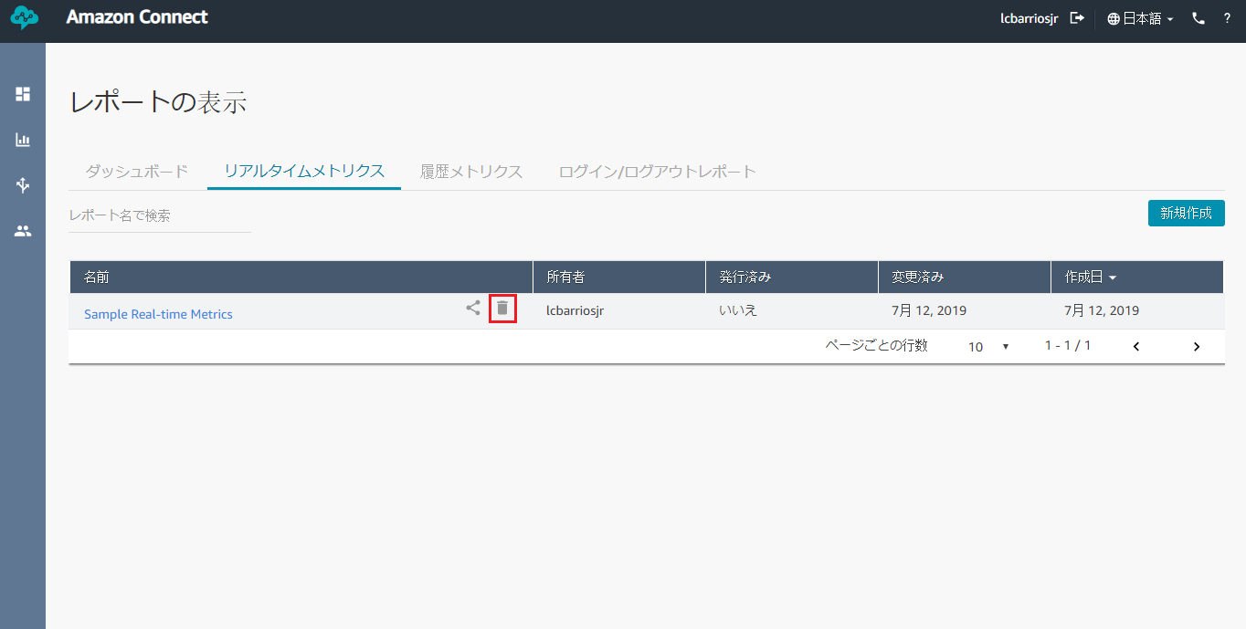

Figure 75. Deleting Saved Real-time Metrics

## **Downloading Real-Time Metrics**

* To download a metrics table, click on the arrow down button beside the blue “Save” button on the upper-right corner of the page.

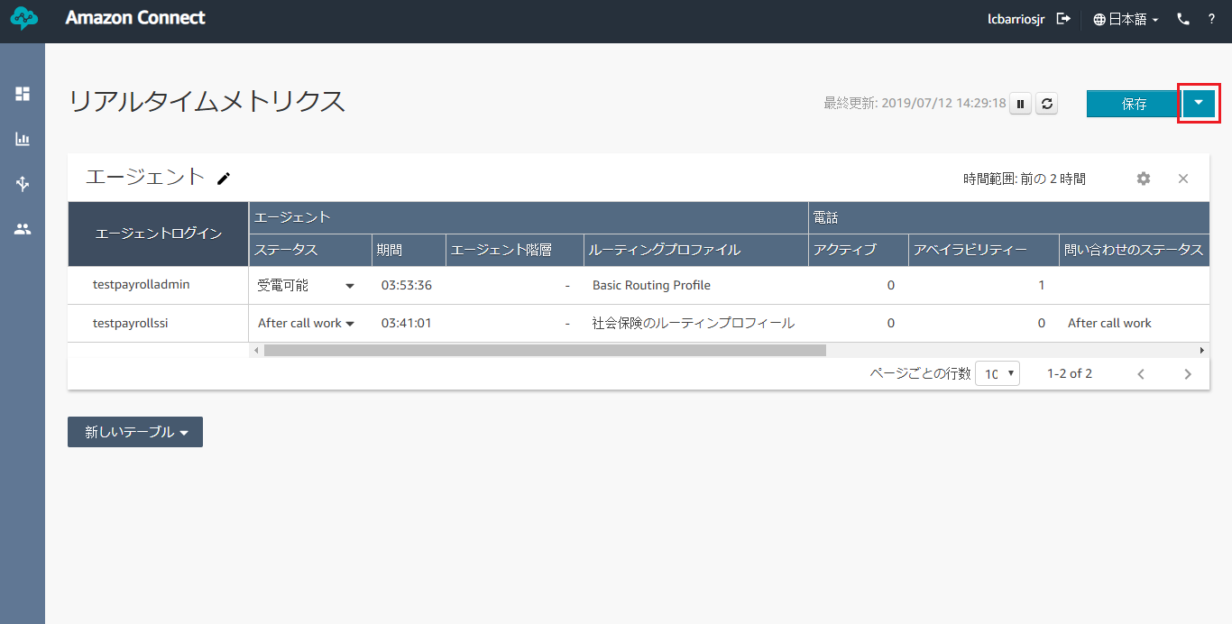

Figure 76. Real-time Metrics Dropdown

* Click “Download CSV” and a CSV file will be created. This will include all the metrics of all the agents in the saved table.

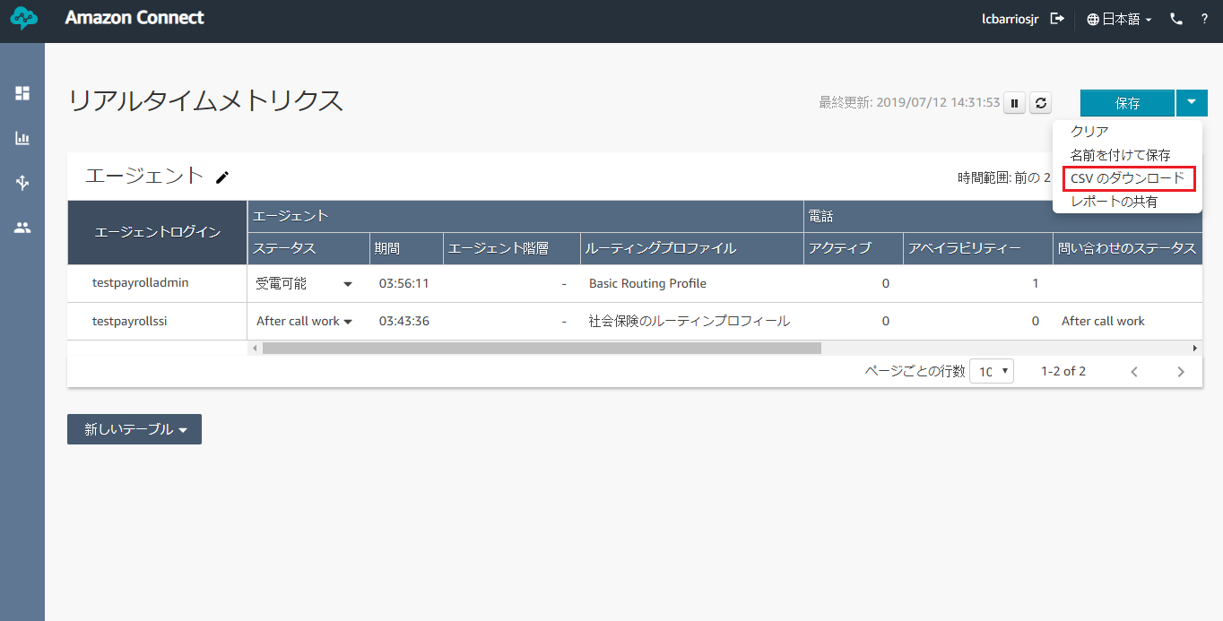

Figure 77. Real-time Metrics Download CSV

* Open the CSV file and you can see the bare data of the metrics.

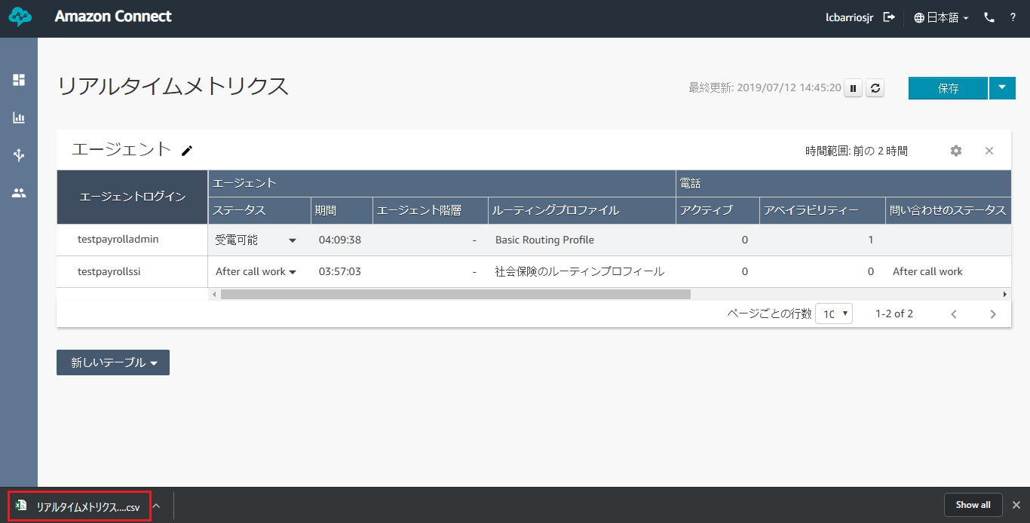

Figure 78. Opening Downloaded Real-time Metrics

* If there are special characters in the metrics (e.g. Japanese characters) there is an extra step to ensure that Microsoft Excel will show the characters correctly:
  + Open a new Excel file.
  + Go to “Data” tab.

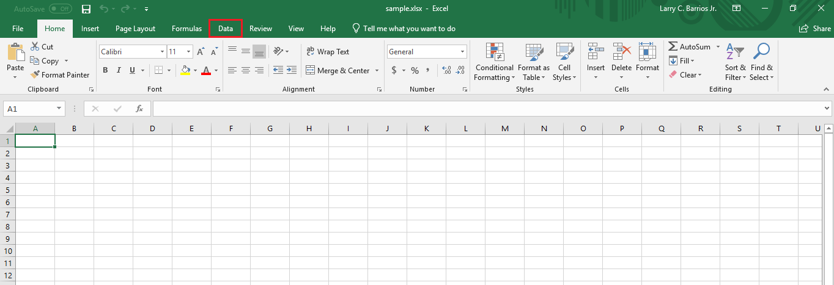

Figure 79. Data tab in a new Excel File

* + On the Get & Transform Data section, choose “From Text/CSV”.

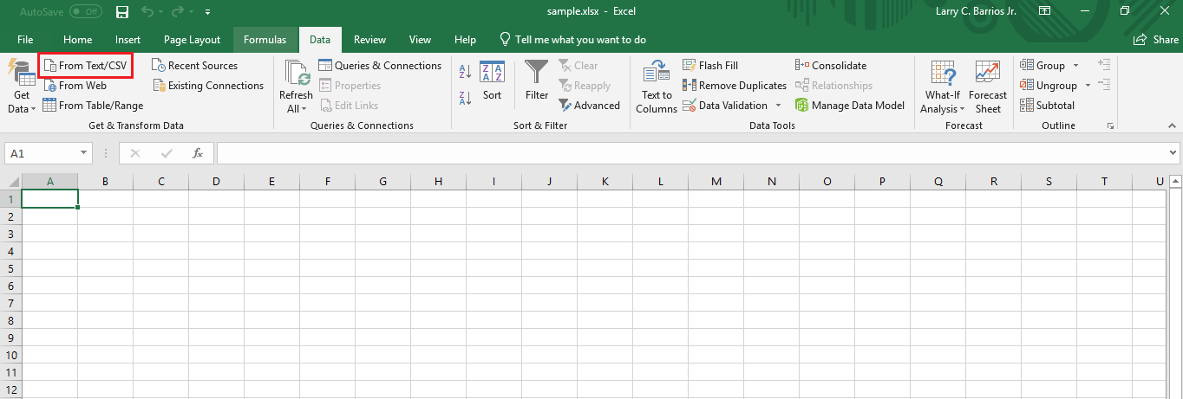

Figure 80. Get & Transform Data section

* + Choose the CSV file created by Amazon.
  + On the File Origin dropdown, select “65001: Unicode (UTF-8)”.

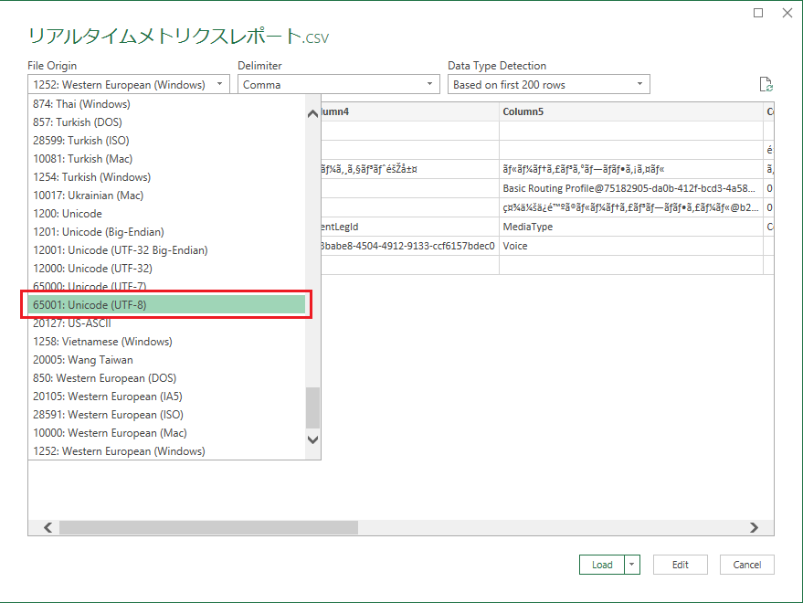

Figure 81. File Origin Dropdown

* + Leave the Delimiter on “Comma”.

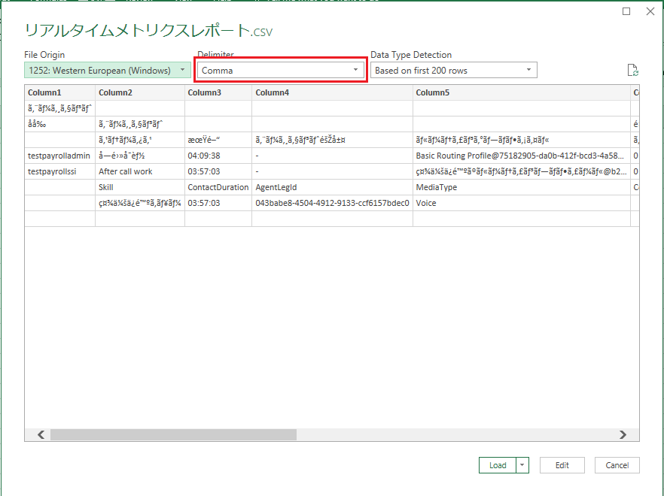

Figure 82. Delimiter Dropdown

* + On Data Type Detection, select “Based on entire datasheet”.

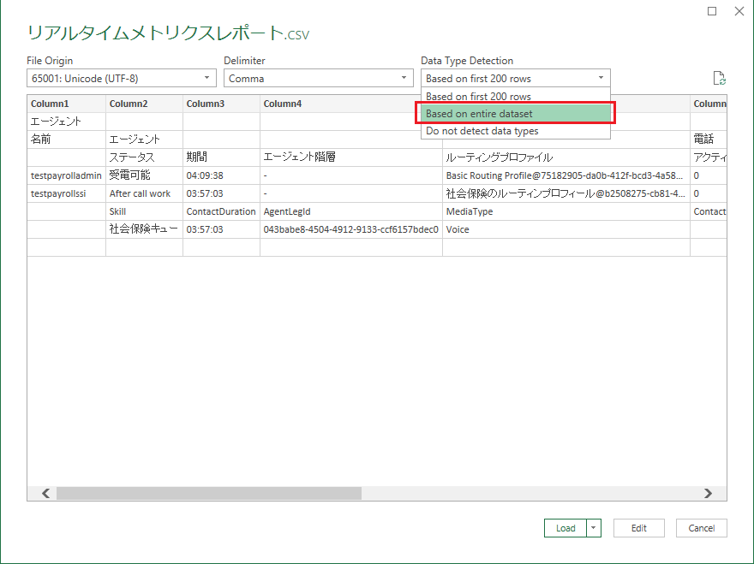

Figure 83. Data Type Detection Dropdown

* + Then, click “Load”.

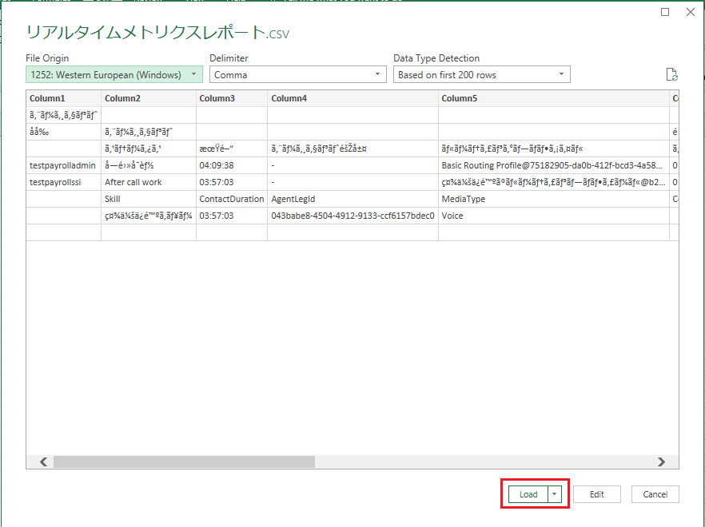

Figure 84. Loading CSV File

* + Don’t forget to save the new file with the loaded CSV table.

# **Historical Metrics**

## **Checking Agents’ Historical Metrics**

* Hover over the second icon in the left navigation bar and click on “Historical metrics”.

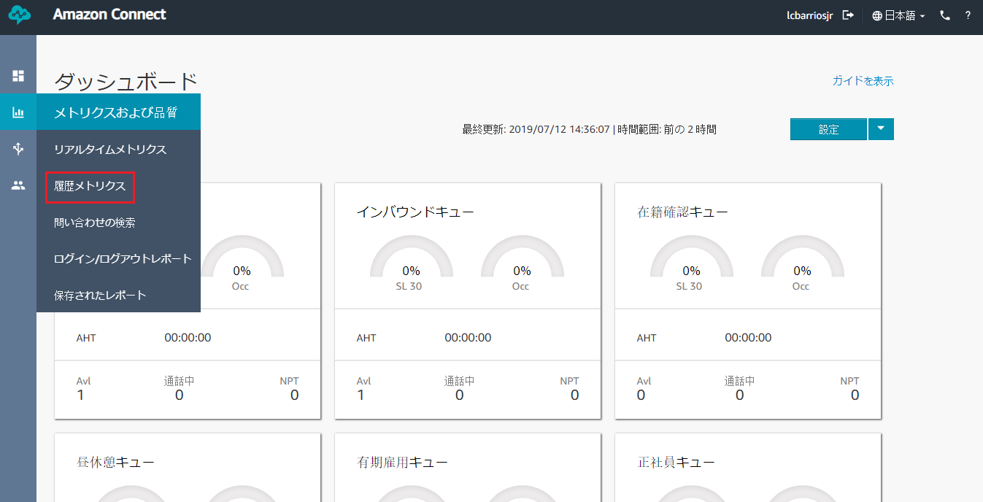

Figure 85. Real-time metrics Link in Metrics and quality

* Click on “Agents” to view the status and metrics for logged-in agents.

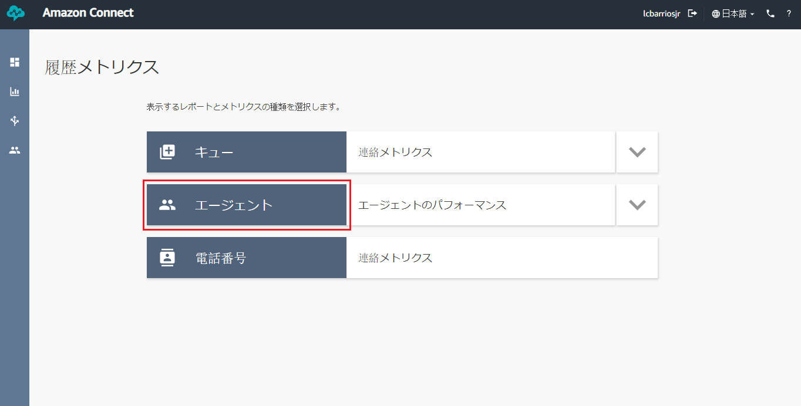

Figure 86. Real-time Metrics for Agents button

* Scroll left or right to view more information about the metrics of each agents. There are multiple metrics that is being monitored in this page:

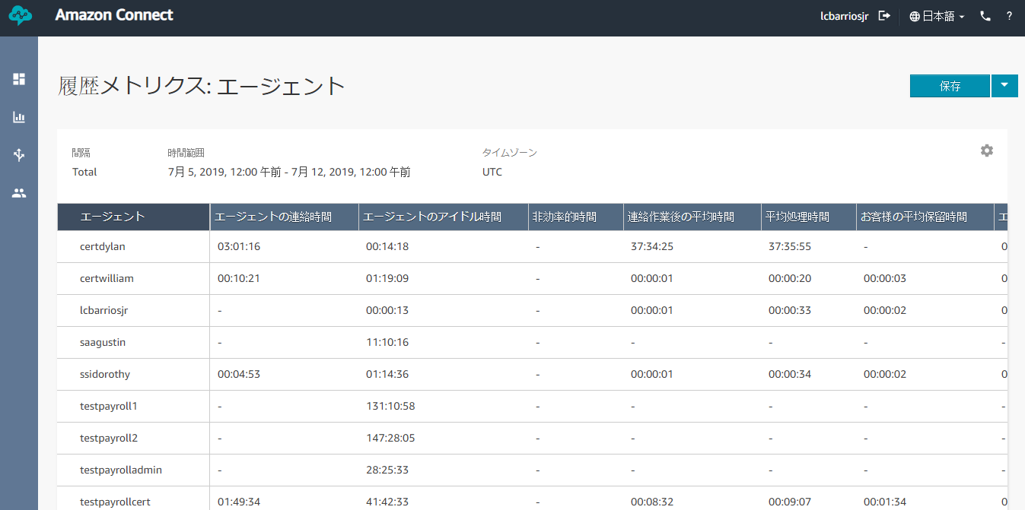

Figure 87.Real-time Metrics for Agents table

* + Agent on contact time – total time that an agent spent on a contact, including hold time and after contact work.
  + Agent idle time – total time that an agent spent in a productive status without handling contacts. The productive statuses include Available and Error.
  + Non-Productive Time – total time that agents spent in a custom status (any status other than Available, Error, or Offline), including any time they spent handling contacts while in a custom status.
  + Average after contact work time – average time that an agent spent in the After Contact Work (ACW) status.
  + Average handle time – average time that agents spent on contacts, including hold time and after contact work.
  + Average customer hold time – average time that customers spent on hold while connected to an agent.
  + Average agent interaction time – average time that agents interacted with customers during contacts.
  + Contacts handled – count of contacts handled by an agent, including both incoming and outgoing contacts.
  + Contacts handled incoming – count of incoming contacts that were handled by an agent, including inbound contacts, transferred contacts, and scheduled callbacks.
  + Contacts handled outbound – count of outbound contacts that were handled by an agent. This includes contacts that were initiated by an agent using the CCP.
  + Contacts put on hold – count of contacts put on hold by an agent one or more times.
  + Contacts transferred out – count of contacts transferred from the queue after being answered by an agent.
  + Contacts transferred out internal – count of contacts for the queue that an agent transferred to an internal source, such as a queue or another agent. An internal source is any source that can be added as a Quick Connect.
  + Contacts transferred out external – count of contacts that an agent transferred from the queue to an external source, such as a phone number other than the phone number for your contact center.
  + Agent answer rate – percentage of contacts routed to an agent that were answered.
  + Agent non-response – count of contacts routed to an agent but not answered by the agent, including contacts abandoned by the customer. A contact can be counted as missed multiple times, once for each time it is routed to an agent but not answered. This metric appears as “Contacts missed” in scheduled reports and exported CSV files.
  + Occupancy – percentage of time that agents were active on contacts.
  + Online time – total time that an agent spent in a status other than Offline. This includes any time spent in a custom status.

## **Saving Historical Metrics**

* To save a metrics table, click the blue “Save” button on the upper-right corner of the page.

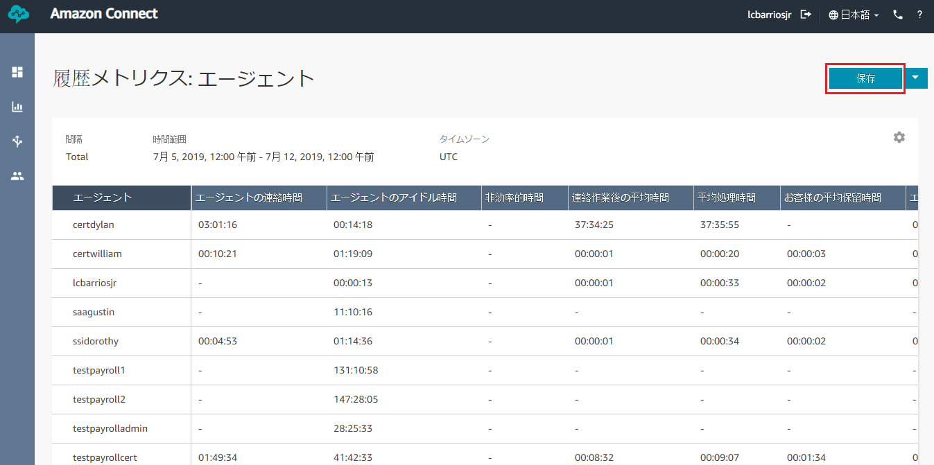

Figure 88. Saving Real-time Metrics

* Provide a name for the metrics and click “Save”.



Figure 89. Real-time Metrics Save Modal

* Hover over the second icon in the left navigation bar and click on “Saved reports”.



Figure 90. Saved reports Link in Metrics and quality

* Choose the “Historical metrics” tab.

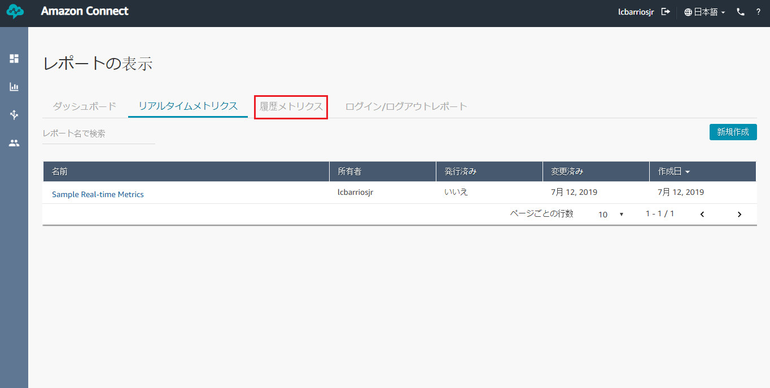

Figure 91. Historical Metrics tab

* Click on the name of the metrics you created to view the metrics table.

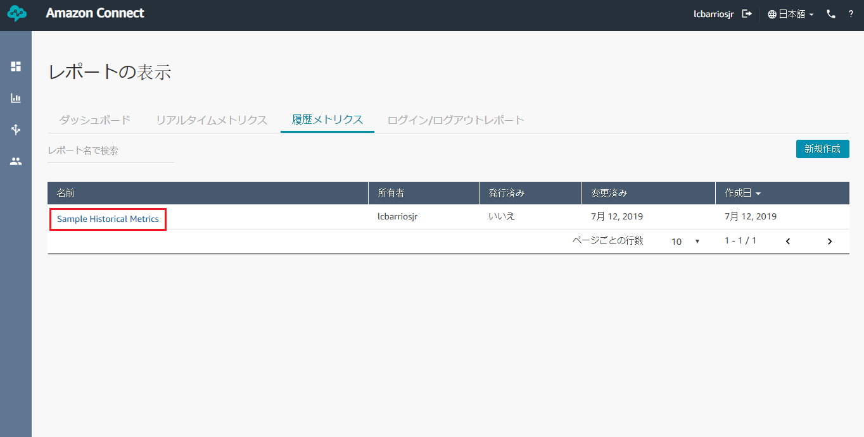

Figure 92. Viewing Saved Real-time Metrics

* To delete the saved metrics, hover over the metrics name and click the trash can icon. Then, click “Delete” to confirm.

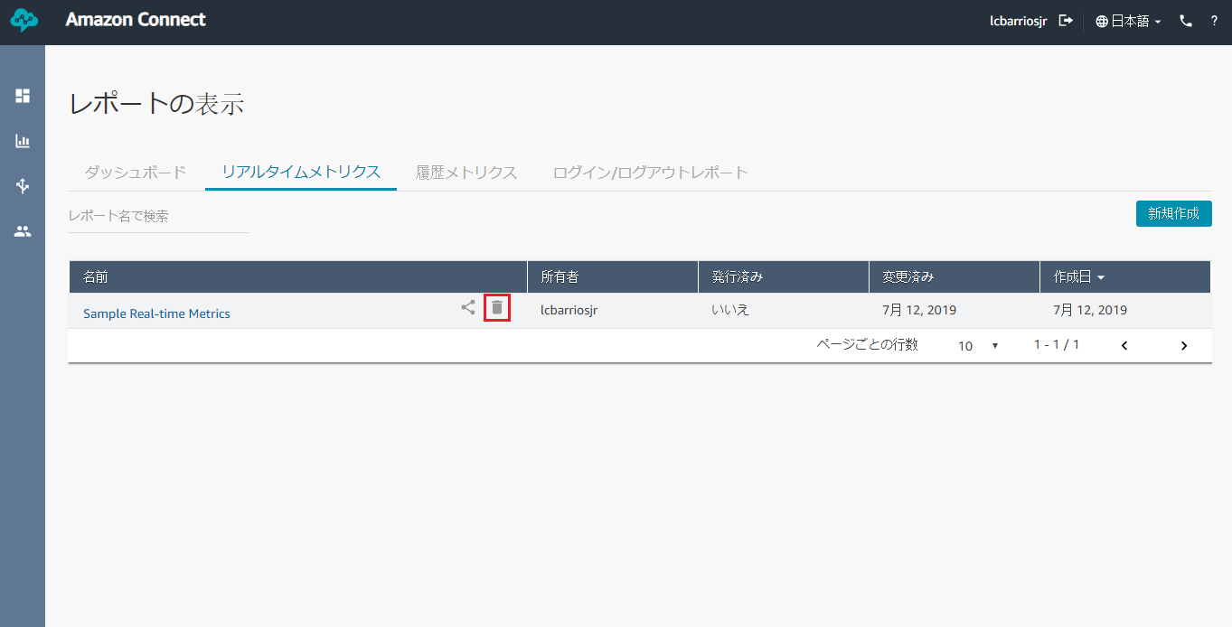

Figure 93. Deleting Saved Real-time Metrics

## **Downloading Real-Time Metrics**

* To download a metrics table, click on the arrow down button beside the blue “Save” button on the upper-right corner of the page.

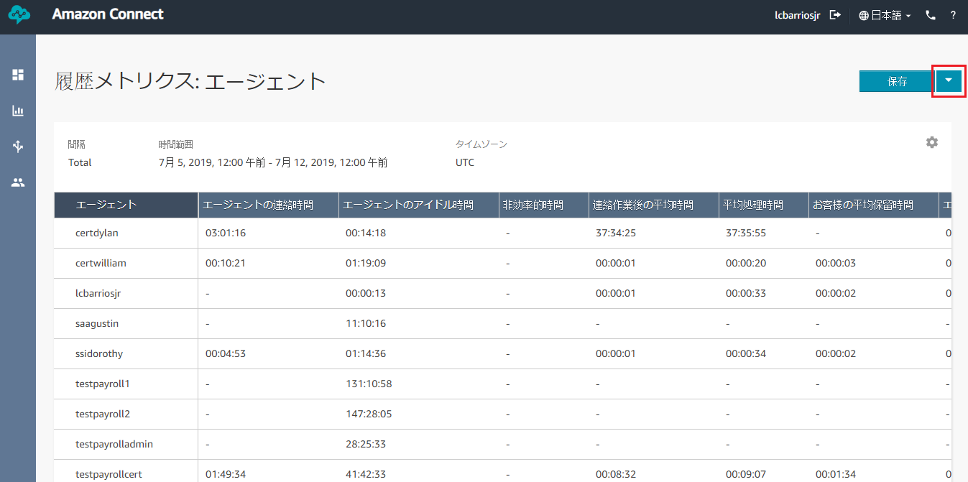

Figure 94. Real-time Metrics Dropdown

* Click “Download CSV” and a CSV file will be created. This will include all the metrics of all the agents in the saved table.

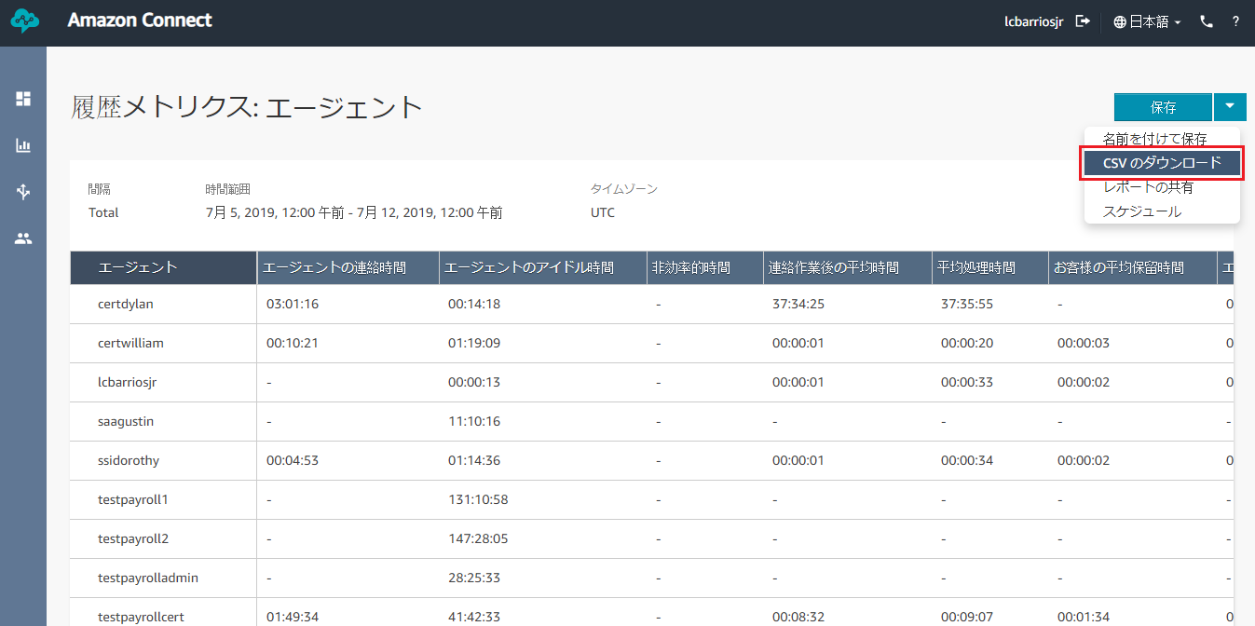

Figure 95. Real-time Metrics Download CSV

* Open the CSV file and you can see the bare data of the metrics.

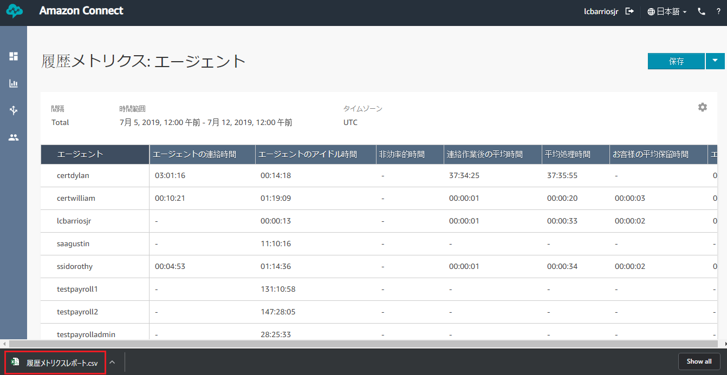

Figure 96. Opening Downloaded Real-time Metrics

* If there are special characters in the metrics (e.g. Japanese characters) there is an extra step to ensure that Microsoft Excel will show the characters correctly:
  + Open a new Excel file.
  + Go to “Data” tab.



Figure 97. Data tab in a new Excel File

* + On the Get & Transform Data section, choose “From Text/CSV”.



Figure 98. Get & Transform Data section

* + Choose the CSV file created by Amazon.
  + On the File Origin dropdown, select “65001: Unicode (UTF-8)”.



Figure 99. File Origin Dropdown

* + Leave the Delimiter on “Comma”.



Figure 100. Delimiter Dropdown

* + On Data Type Detection, select “Based on entire datasheet”.



Figure 101. Data Type Detection Dropdown

* + Then, click “Load”.



Figure 102. Loading CSV File

* + Don’t forget to save the new file with the loaded CSV table.